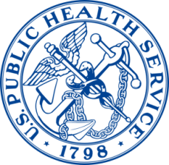
2015 Public Health Leadership Seminars

hosted by the

Office of the Assistant Secretary for Preparedness and Response

with the

Office of the US Surgeon General

General Information

The Public Health Leadership Seminars, hosted by the US Department of Health and Human Services’ (HHS) Office of the Assistant Secretary for Preparedness and Response, are available to HOSA-Future Health Professionals members, students, alumni and advisors, who are interested in learning about public health while interacting with leading professionals within the Office of the Assistant Secretary for Preparedness and Response (ASPR), Office of the US Surgeon General (OSG) and the United States Public Health Service Commissioned Corps (USPHS). For a short period of time, seminar participants are able to experience first-hand the mission of HHS, ASPR, and the OSG, as well as responsibilities carried out by USPHS officers.

Participants will engage in interactive discussion sessions with staff and complete a group project that expands HOSA’s public health, emergency preparedness, response and recovery, or resilience resources and knowledgebase. Following the seminar, participants may also have the opportunity to present their experience during an educational symposium at the 2016 HOSA National Leadership Conference or other appropriate venues.

This Public Health Leadership Seminar is designed to afford HOSA members the opportunity to enhance their knowledge, refine professional capabilities and increase their awareness of the infrastructure, operations and responsibilities of HHS, ASPR, OSG and USPHS.

Goals and Objectives

HOSA-Future Health Professionals seeks to provide its members with an experience that exposes them to the many issues and career paths found in the field of public health, especially in the governmental, leadership and policy arenas. HOSA students, alumni and advisors are specifically encouraged to use the seminar as an opportunity to gain awareness and understanding of the significant role played by HHS, ASPR, OSG and the USPHSN in advancing the health and safety of our nation.

Seminar Goals

Participants in the Public Health Leadership Seminar will:
- gain awareness and understanding of public health issues and careers
- improve knowledge base through interaction and discussion with key public health leaders within HHS, ASPR, OSG, USPHS and other organizations
- strengthen HOSA’s partnership with HHS, ASPR, OSG and USPHS

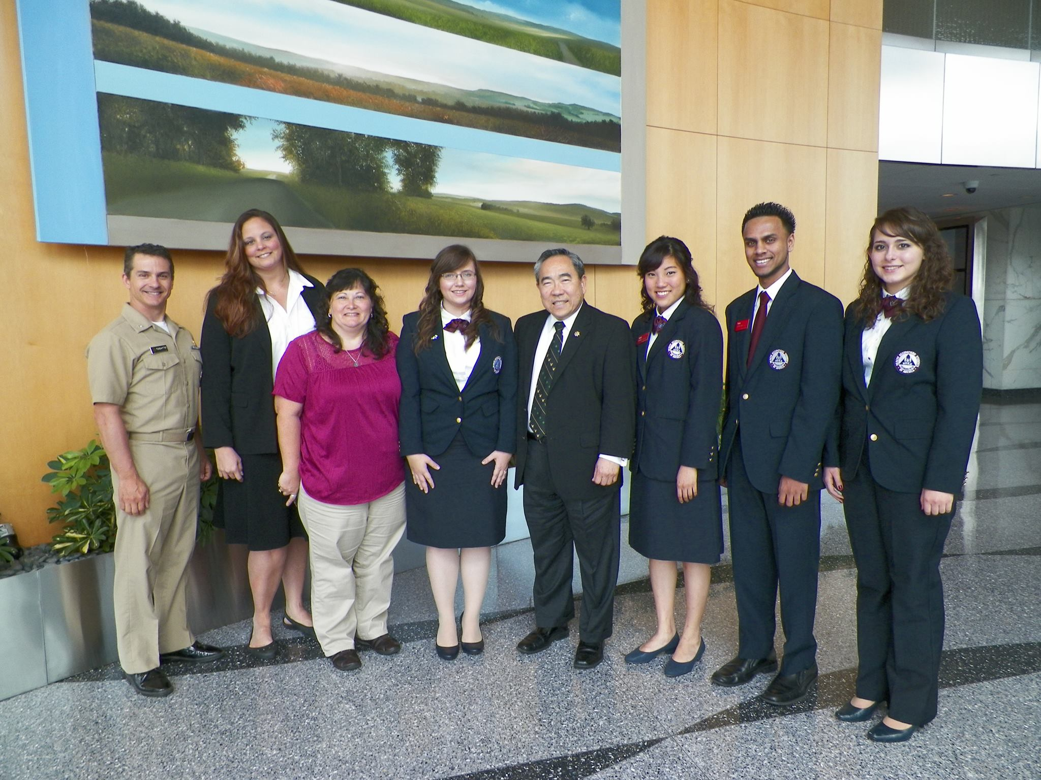
Seminar Objectives

- Provide opportunities for participants to interact with leaders within and outside HHS (as schedules permit)
- Meet with key HHS, ASPR, OSG and USPHS professionals
- Tour the HHS Secretary’s Operations Center
- Visit the Uniformed Services University
- Guide participants as they develop and work together on a project that expands HOSA’s resources or knowledgebase
- Promote career paths in public health
- Encourage participants to commit to service to others, their communities and their nation

Participant Deliverables/Expectations

- Actively participate in all discussions and interactions
- Participate in development of group project, and in a presentation about the project on the final day of the seminar. Past projects included the development of a “youth engagement in public health” resource guide and a proposal for “Let’s Move! HOSA.”
- Prepare elevator speech detailing the host program, HHS, ASPR, OSG and/or USPHS
- Document experience, with photographs, through daily updates that may be shared with other HOSA members via the HOSA blog and social media (Facebook and Twitter)
- Provide HOSA National with electronic copies of any documents received
- Identify activities and opportunities that can be shared with HOSA members and chapters
- Participate in a “hotwash” discussion about the seminar

Travel, Lodging and Logistics

- Participants are responsible for their personal travel arrangements to and from Washington, DC
- Participants must arrive the day before the seminar begins and check in with National HOSA via phone call or email upon arrival
- Participants are expected to be present for the entire seminar period, therefore departure arrangements should be made for the evening of the last day or later
- Participants are responsible for any lodging costs and local transportation fares (typically via subway)
- While participants may stay with family or friends, it is highly recommended that all seminar participants stay in the same hotel to facilitate camaraderie, networking and group work on the project
- Past participants found it helpful to share rooms
- Hotel selected should be close to a metro stop (http://www.wmata.com/)
- ASPR office is located at 200 C Street SW, Washington, DC, and is very close to the Federal Center SW metro stop on the blue, orange and silver lines

Code of Conduct

- The Code of Conduct form for the HOSA National Leadership Conference will be used for student participants. The form must be signed prior to the seminar
- The HOSA uniform is mandatory for student participants and business attire is required for advisor/alumnus participants for all meetings
- A waiver must be obtained from parent or guardian to show understanding that the student will be largely self-supervised

Eligibility Criteria

HOSA Student Participant:
- Must be a member of HOSA
- Must be currently enrolled in a high school, trade school, technical or vocational institution, junior college, college, university or other accredited educational institution
- Must be no less than a senior in high school at the time of the application submission and at least 17 years of age during the seminar
- Must sign a written document of agreement outlining the role and responsibilities prior to, during and following the seminar

HOSA Advisor or Alumnus Participant:
- Must be a member of HOSA
- Must be a local or state advisor, or a HOSA alumnus

Timeline/Due Dates

- May 1 All applications are submitted to National HOSA
- May 10 National HOSA submits top applicants to host review committee
- May 25 Host review committee submits recommendations to National HOSA
- May 30 Final decision by National HOSA. Applicants notified of their acceptance status
- June 10 Selected participants send Signature of Commitment form to National HOSA

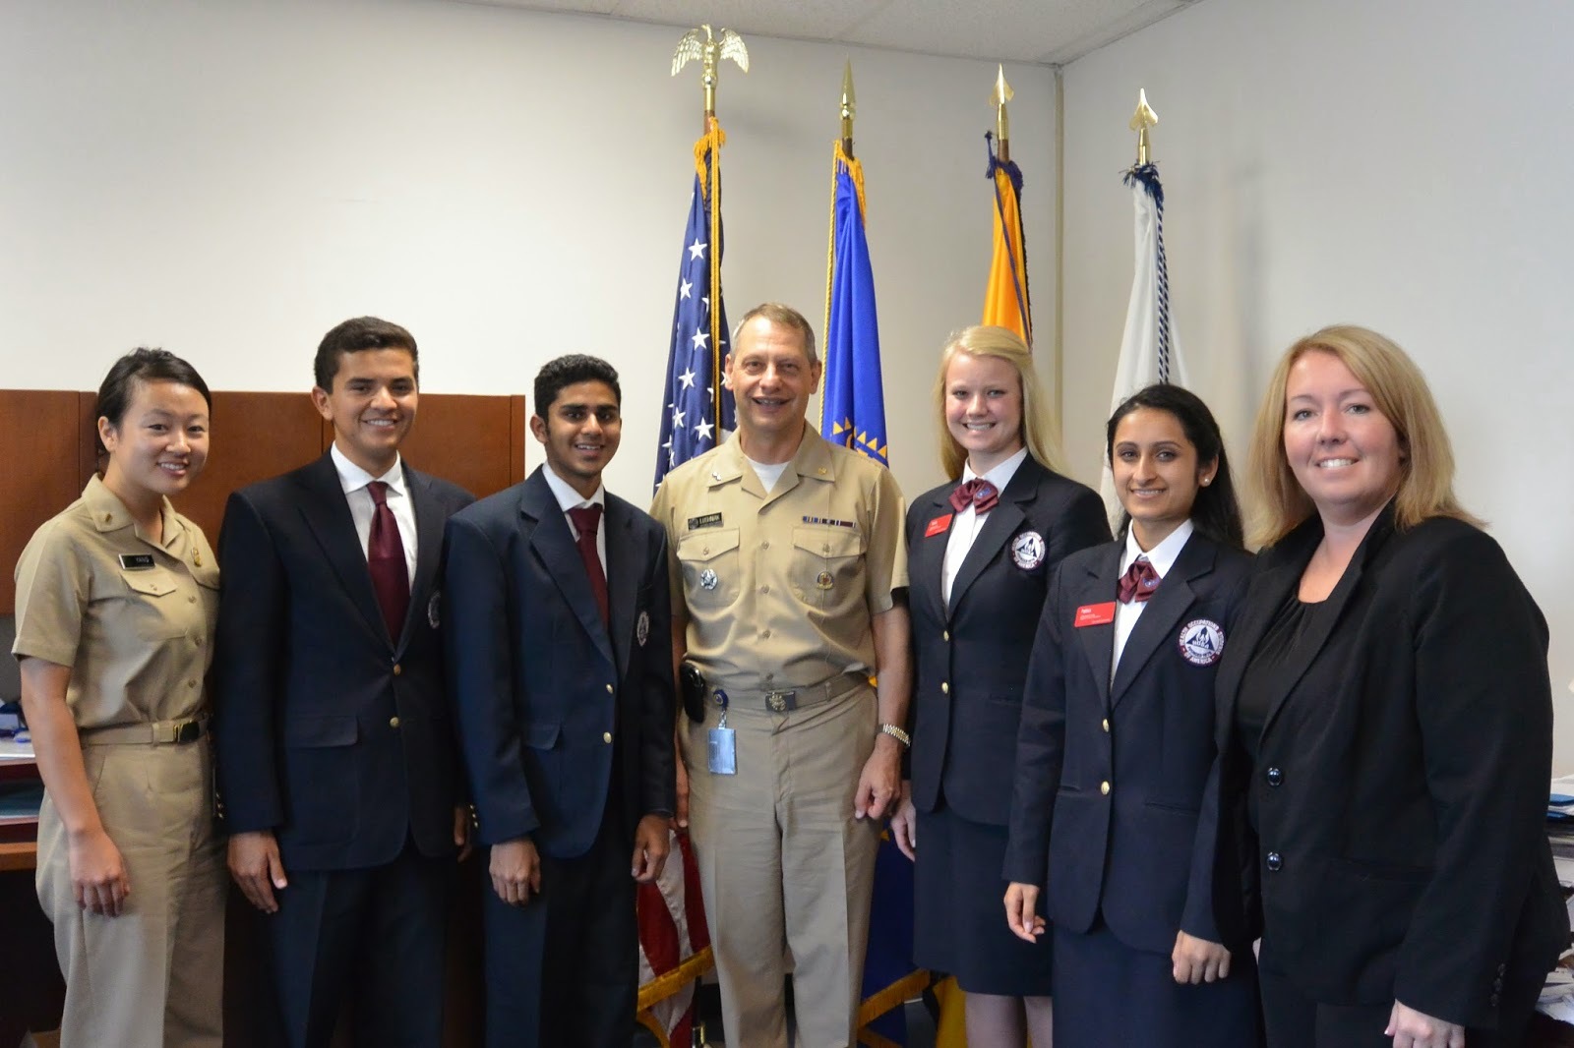

Application Instructions

No application will be considered complete until ALL of the following items are received:
- a cover letter
- a current resume
- two letters of recommendations
- completed seminar participant application

Your cover letter should outline why you would like to be selected for the Public Health Leadership Seminar, and briefly summarize your HOSA experiences, community involvement and job-related or mentorship experiences.

Letters of recommendation can be obtained from:
- health science instructor
- HOSA chapter or state advisor
- school administrator
- healthcare/community leader

You must complete the entire seminar participant application form. Incomplete and handwritten forms will NOT be considered for acceptance.

When all documents are completed, the seminar participant application MUST be sent as one email package to hosa@hosa.org, with the subject heading: Public Health Leadership Seminar Application.

If you have any questions, please email hosa@hosa.org or call 972.874.0062.

For More Information about the Public Health Leadership Seminar Hosts:

Department of Health and Human Services – http://www.hhs.gov
Office of the Assistant Secreatary for Preparedness and Response – http://www.phe.gov
Office of the U.S. Surgeon General – http://www.surgeongeneral.gov
United States Public Health Service Commissioned Corps – http://www.usphs.gov
Division of the Civilian Volunteer Medical Reserve Corps – http://www.medicalreservecorps.gov

