PROCESS REVIEW: Event Evaluation Process

With the exception of Healthcare Issues Exam, a Scantron evaluation form will be completed by all competitors in all HOSA competitive events.

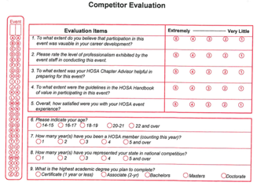

For events that have a Round Two, an additional separate paper/pencil evaluation form will be used, similar to the below.
HOSA ROUND TWO EVALUATION FORM
Event __________________________ Division (circle one): Middle School Secondary PSC
Overall rating of the event: (5 being the best)
Congratulations! Qualifying as a Round Two competitor at the HOSA International Leadership Conference means you have distinguished yourself among your peers, and should feel pride in your achievements.
Your thoughtful, specific feedback and suggestions will help us improve our organization and better serve HOSA members for the future.

Comments:

OPTIONAL: Name ___________________________ School ______________________ State ____

