

**Process Review: Scantron Forms**

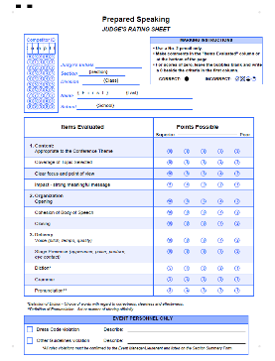HOSA-Future Health Professionals uses pre-slugged Scantron judge rating forms. When used properly, these forms greatly increase accuracy and decrease the time needed to tabulate events.

**BEFORE THE EVENT** - Events with appointment times:

* Group Scantron forms by section in order of competition.
* Be sure you have one form for each judge.
* Be sure the right form is being used to rate the competitor by introducing the competitor to the judges by name and school or ID #.

**BEFORE THE EVENT** - Tests, or when all competitors begin at the same time:

* Group Scantron forms in the order they will be distributed. (For individuals, usually alpha by last name. For teams, usually alpha by school.)

**JUDGES MUST:**

* Use a #2 pencil
* Bubble the entire bubble
* Make comments on the bottom or back of the form, or in the “Items Evaluated” column
* Make a notation regarding any scores of zero.
* Fairly and consistently award guidelines (process) points if they are a part of the rating sheet.
* Do not write on the edges of the Scantron form.

**MC900300063[1]PERSONNEL MUST:**

* Check each rating sheet for one mark per criteria and zeros.
* REFRAIN from using paper clips on forms to be scanned.
* Take responsibility to ensure the form is filled in correctly, including the Event Personnel section at the bottom of the form.
* **There MUST not be writing in the margins of the paper. This will prevent proper scanning.**
* Separate completed forms from unused forms before turning them into Tabulations. You may paperclip unused forms to be recycled.

**TROUBLE SHOOTING**

1. If you have a form with no competitor listed, chances are they were deleted after the forms were printed. Mark giant X through form and note on the top “No Show.”
2. If you have a name listed with no form, chances are they registered late. Use a blank rating form, fill in the name, school, division, and state, and use a post-it to flag the form when collected so that Tabulations will add an event ID # *before* the form is scanned.
3. During large tests, you may need to give out the correct Scantron forms, and check them off your printout after the event. (Understanding how important it is to get the event started on time.)
4. DO NOT combine forms to be scanned with forms that are NOT to be scanned (such as no-shows.) The forms that should not be scanned CAN be paper clipped together and noted as “NOT TO BE SCANNED.”
5. Be sure you are working from an updated event printout, listed in the order needed. (By section, by school, by last name, etc.) If you have any doubts about having the current event printout, be sure to ask the Lieutenant for assistance.
6. When turning in test Scantrons, count the number of forms to be scanned, and write it on a post-it note and place it on the top of the first test form.
7. 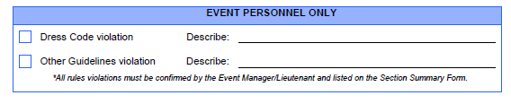IF the tables have tablecloths, show competitors how to place the Scantron form on the actual test booklet to provide a smooth surface when bubbling an answer.

**THE EVENT PERSONNEL BOX**

* This box is to be left blank UNLESS there is a violation of the rules.
* The Section Leader confirms the violation with the Event Manager before marking the box, and before the competitor leaves the event site. (If appropriate.)
* The Section Leader transfers all violation information to the Section Summary form.
* The Event Manager & JM reviews all violations with the Lieutenant during or after the event. Confirmed violations must be initialed by the Lieutenant.

WHY?

*Our past history shows that individual advisors have different interpretations for process violations, particularly for dress code. In order to provide a fair and consistent event experience, we want to ensure that all competitors are being held to the same high standard. For that reason, we will continue to enforce the dress code as written in the event guidelines, and will not penalize competitors for appearance issues that are not a direct dress code violation. Lieutenants trained by HOSA-Future Health Professionals must be included in this process to ensure a consistent outcome across events.*