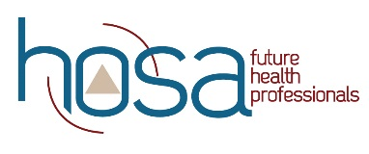
HOSA Mini Lesson: Communication

Objectives:
Upon completion of this lesson, students will have sufficient knowledge of, and be able to:
- define communication.
- illustrate the communication process.
- outline the possible barriers in communication process.
- propose methods to decrease communication barriers in healthcare.
- describe the ways to increase cultural competence.
- compile information on religion, rituals or health and illness and one assigned culture.
- construct a speech on Unlocking Your Potential.
- Problem solve a communication issue in the healthcare setting.

Time:
- Lecture on communication– one class period
- Compile information on assigned culture- Two class periods
- Construct speech – one and half class periods
- Problem solving activity – one class period

Materials:
- Internet access
- HOSA – Future Health Professionals Competitive Events Guidelines

Instruction:
- Share PowerPoint on Communication (19.56 minute video)
- Work in group to share information with peers on assigned culture.
- Write speech on “Unlock Your Potential”.
- Problem solving activity.

Assessment:
- Presentation to peers on assigned culture project for health career.
- Speech evaluated using Prepared Speaking Guidelines.
- Problem solving activity solution evaluated using Creative Problem Solving Guidelines.

Standards:
NCHSE
2.1.1 Model verbal and nonverbal therapeutic communication.
2.1.2 Identify common barriers to communication.
2.1.4 Interpret elements of communication using sender-message-receiver feedback model.
2.1.5 Modify communication to meet the needs of the patient/client and be appropriate to the
situation
2.1.6 Describe appropriate interactions with patients throughout various stages of psychosocial
development.

For additional Curriculum Crosswalks see CE Useful Tools

