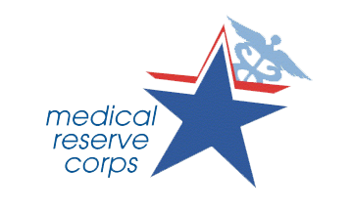
Examples of MRC and HOSA Activities

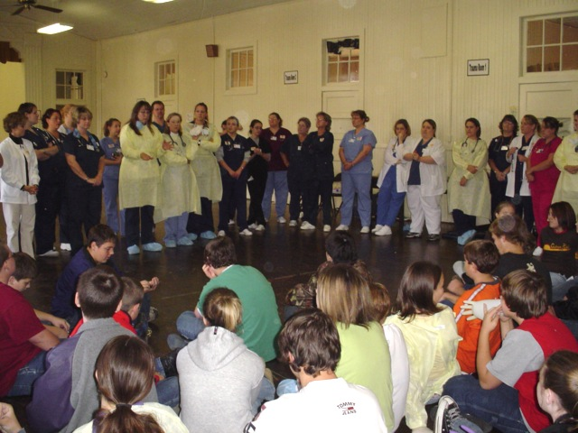
- Staffed a booth in a local mall to recruit adult MRC members.

- Created a Facebook group page for the local MRC to promote interest in the MRC Partnership.

- Encouraged Medical Reserve Corps and Public Health Service officers to serve as guest speakers at student organization meetings.

- Surveyed local health care facilities to determine the number of health care professionals who would be willing and available for a disaster.

- Participated in Regional Exercises. Scenario: the water supply is contaminated and hundreds of people become ill. Students worked in the call center simulating the work needed to secure placement of patients in hospitals out of the area as the local hospital reached capacity. Students were introduced to the Incident Command System and the National Incident Management System.

- Completed the courses provided by FEMA on ICS and NIMS. The courses completed were:

- IS-100.a-Introduction to the Incident Command System
- IS-200.a-ICS for Single Resources and Initial Action Incidents
- IS-700.a-National Incident Management System (NIMS), An Introduction.

- Distributed pamphlets during school lunches regarding emergency preparedness that included supply list and emergency preparedness booklets.

- Visited a preschool using the Sesame Street Emergency Preparedness program, “Let’s Get Ready.” Each child received a booklet to learn to provide critical information, including: phone numbers and parents’ full names. The booklet also included tips to build a family emergency kit.

- Distributed booklets at a mall on how businesses can be prepared for emergencies. The booklets explained how to evacuate a building, ways to exit a building safely and how to assist others during a disaster.

- Shared information with high school and middle school students on sun exposure and skin health.

- Assisted with H1N1 Vaccination Clinics by escorting people in and out of the clinic.

- Delivered meals to Senior Citizens and provided literature aimed at preparing seniors for natural and manmade disasters.

- Promoted HOSA to Medical Reserve Corp Volunteers

- Visited high school classrooms as a guest speaker to explain the Medical Reserve Corps and its mission.

- Taught proper handwashing techniques to pre-school and elementary students.

- Conducted CERT training with Jr. MRC members taught by MRC volunteers.

- Instructed students in Psychological First Aid.

- Taught the community about West Nile Virus. Distribute flyers and brochures with information about the virus and the importance of proper precautions at local malls and high schools.

- Assisted with Be Safe Saturday that was presented by a MRC Unit. Activity included health and safety display booths. Staff working at the booths educated visitors to the booth, handed out information and provided demonstrations. Students had a booth that concentrated on health, fitness and emergency preparedness with the information given being youth friendly. Students also played games at their booth to educate students on fitness and nutrition as well as a game to teach youth what to pack in an emergency kit.

- Distributed H1N1 flu information to school and community by setting up information centers in various community locations.

- Assisted with H1N1 flu vaccine clinic by escorting clients to and from the medical station.

- Contacted local health care professionals to recruit members for local MRC.

- Volunteered as victims and volunteers at local CERT trainings

- Made disaster kits for victims of local and national disasters. Might include blankets, water, non-perishable foods, basic first aid supplies

- Got involved in activities that promote public safety in the community

- Sponsored a poster contest in schools to promote the Surgeon General’s priorities, then, hang the posters throughout schools and community businesses.

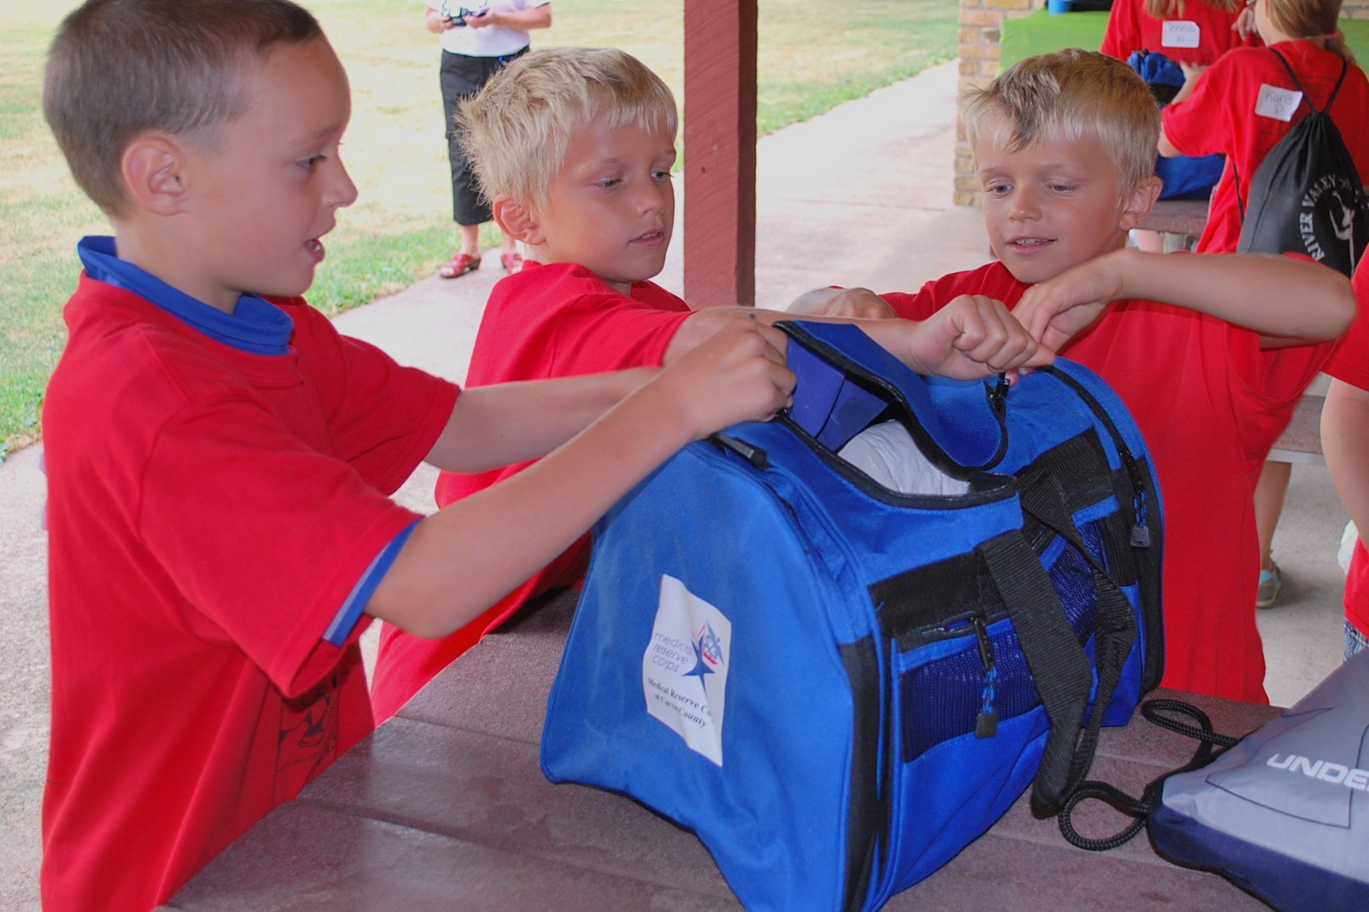
- Worked with a local YMCA or health club to promote community-wide or school-wide Healthy Week or Month. During this month, new members to the YMCA or health club can attend for free.

- Visited the elementary school or pre-school and teach FUN exercises.

- Created a Public Service Announcement on a disaster that can affect your community and report it on a local radio station. Media outlets have to provide free time for PSAs.

- Served as host site for a Medical Reserve Recruiting meeting or Volunteer Orientation Meeting. Have snacks and information available about HOSA-Future Health Professionals.

- Invited MRC/PHS volunteers to serve as judges for local, regional and/or state HOSA competitive events.

- Worked with a local MRC to develop a campaign to observe Health Disparities Month (whatever the health disparity is in your community) in Your Community.

- Organized with local MRC health care professionals a Discount Physical Day for the community where health screenings are provided.

- Developed activities in your school that combats Obesity, Smoking, Exercise and Healthy Environment. Customize the activities to the specific needs of your community.

- Established a mentoring program for MRC and Jr. MRC members.

- Worked with a MRC to teach CPR classes in the schools and communities.

