Advisor Guide to
Youth Engagement in the
Medical Reserve Corps

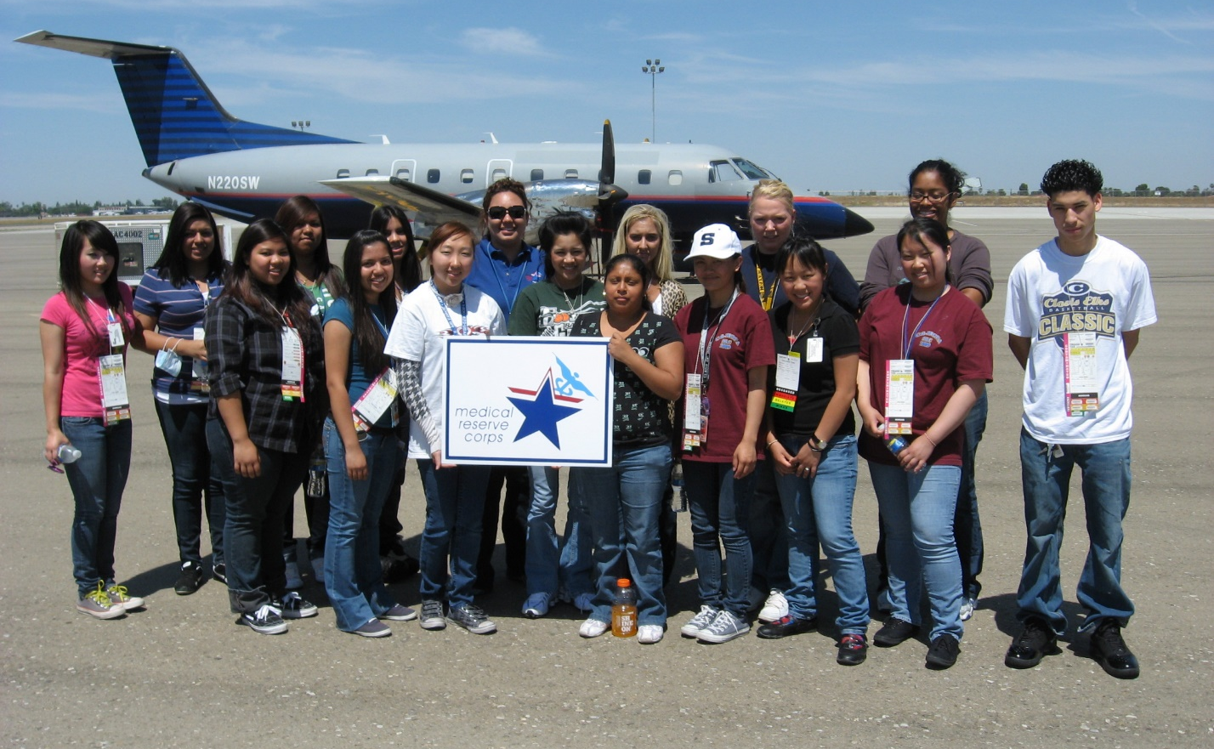

Contents

Introduction to Public Health and the MRC 3-4
What is Public Health?
What is the MRC?
Why the MRC is Needed?

Why Should Youth Engage in Public Health and with the Local MRC? 4-5
Benefits of Youth Engagement in the MRC
Testimonial from an Advisor

How Can Youth Engage with the Local MRC? 6-8
Join as a Member of a MRC Unit
Partner with the MRC through a Student Organization
Create a Junior MRC

What Can Youth and the MRC Do Together? 9

How to Further Existing MRC Relationships 10

Next Steps 10

Appendices 11-24
Appendix A – Sample Email to MRC Unit Leader
Appendix B –Medical Reserve Corps Parent Information Handout
Appendix C – Sample MRC Unit/Housing Organization Consent Form
Appendix D – Potential Barriers/Solutions
Appendix E – Sample Unit Lesson Plan
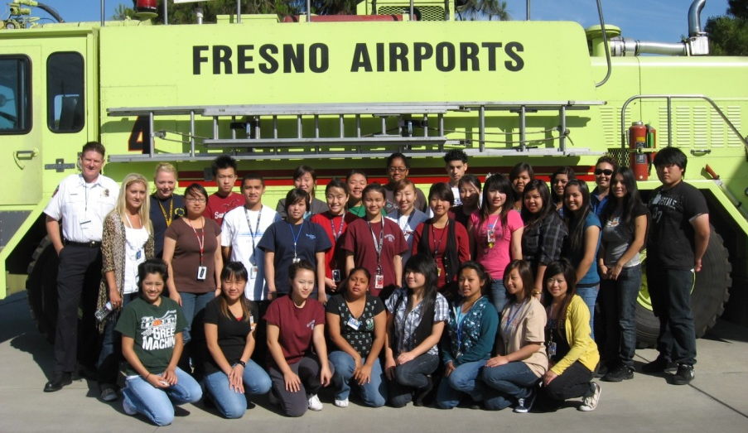

Introduction to Public Health and the MRC

What is Public Health?

Public health is an exciting and growing field of study that is increasing in importance every day. Public health advocates for health through efforts aligned to prevent disease, increase longevity and improve population health. The field tackles numerous health issues, such as improving access to health care, controlling infectious disease, and reducing environmental hazards, violence, substance abuse, and injury.

Public health professionals come from wide variety educational backgrounds, and are leaders who meet the many exciting—and often complex—challenges in protecting the public’s health today and in the future.

What is the MRC?

The Medical Reserve Corps (MRC) is a national network of local volunteers who strengthen public health, reduce vulnerability and disaster risk, build resiliency and adaptive capacity, and improve community preparedness, response and recovery capabilities.

The MRC is made up of a variety of medical and public health professionals as well as other volunteers. Some of the many disciplines represented in the MRC units include:

- Physicians
- Physicians Assistants
- Nurse Practitioners
- Nurses
- Pharmacists
- Dentists
- Veterinarians
- Behavioral Health
- Respiratory Therapists
- Public Health
- Other Disciplines
- Non-Public Health/Non-Medical Volunteers

For more information and/or to find a local MRC near you, visit http://www.medicalreservecorps.gov

Why the MRC is Needed?

In times of crisis – be it a hurricane, a flood, a disease outbreak, or even man-made disaster – medical and public health professionals often want to rush in, eager to volunteer in support of emergency relief activities. The Medical Reserve Corps provides an organized approach to identify these volunteers, provide training and align everyone’s efforts to provide the greatest impact.
MRC units throughout all fifty states in the U.S. support local public health initiatives, as well as prepare for and respond to disaster and emergency situations when disaster strikes their community. From conducting annual flu clinics, to running first aid booths at county fairs, to deploying in hurricane response situations, MRC volunteers are dedicated to strengthening the health of their communities. In doing so, they make their cities and towns more resilient to any crisis. The healthier a community is before a disaster, the better able they are to bounce back.

Why Should Youth Engage in Public Health
and with the Local MRC?

Young people make important contributions to communities in many ways, and an increasing number of youth want to participate in public health initiatives and activities. Their participation in public health not only improves the health and preparedness of the communities, but also helps youth develop leadership, service and other skills. Coordinating youth participation in a local MRC unit is a great way to engage and expose youth to public health as well as allow them to learn and serve. The field of public health can offer great personal fulfillment to young people: working towards improving the health and wellbeing of their community is quite often a rewarding endeavor.

As a youth advisor, you play a key role in determining student volunteerism efforts. Helping your youth become involved with their local MRC unit is a fantastic way to utilize existing infrastructure to teach your students and allow them to have “real world” experience within public health while still in school.

Benefits of Youth Engagement in the MRC

- Increased self-esteem, leadership, development of professional/medical skills

- Introduction to adults: mentorship and shadowing opportunities with community and public health leaders
- Better academic achievement
- Résumé building
- Networking with other youth and professionals
- New perspectives
- Sense of purpose

Testimonial from an Advisor

When presented with a request from my students to compete in HOSA’s MRC competition, I wasn’t sure where to begin. Searching the internet led me to the MRC website, through which I was able to locate our local MRC Regional Coordinator. It was very challenging in the beginning because neither of us had any understanding about the organizations we were each involved in. After several staff members gave a presentation to my classes and visited with our members, our chapter and local MRC unit partnered together. We have participated in a number of events such as assisting at health screenings and educational trainings. The partnership has been great because our members have learned so much through their involvement with the MRC.
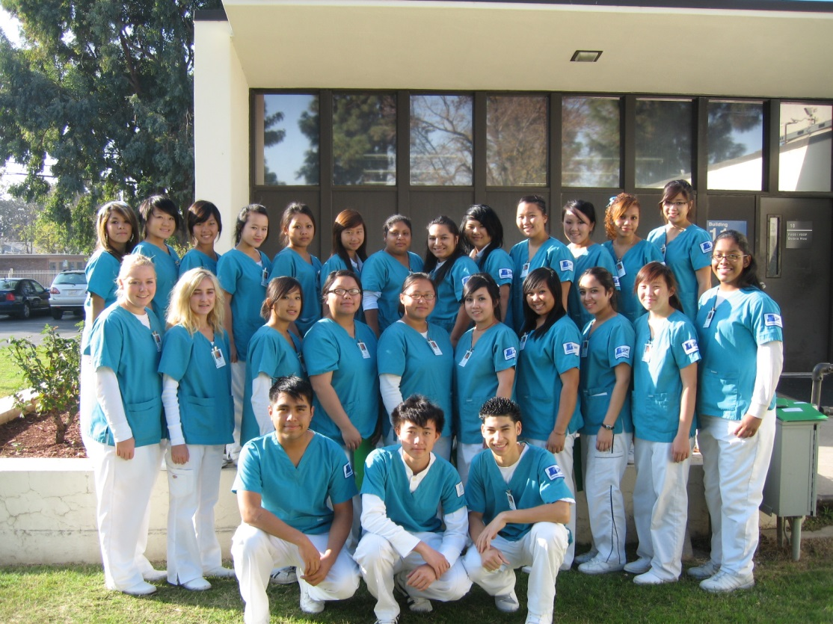
—Christina Isong, HOSA Advisor, Summit High School, TN

How Can Youth Engage with the Local MRC

There are three different ways that a youth organization can engage with a local MRC unit, including joining the MRC, partnering with the MRC, and creating a Junior MRC unit. Below is an overview of how to implement each option, though the experience of each organization will be different.

Join a MRC Unit

- Find your nearest MRC unit at http://www.medicalreservecorps.gov/FindMRC by entering your zip code and reach out to the local MRC unit leader. Ask to attend their next Medical Reserve Corps general body meeting. A sample email is located in Appendix A. At the meeting, suggest where you and the youth could potentially play a role within their unit.
- Another simple way to get your foot in the door is to extend an invitation to the MRC unit leader to your next general body meeting. Ask them to provide a presentation on public health and the Medical Reserve Corps for your youth.
- Provide parents with Medical Reserve Corps Parent Information Handout (see Appendix B for a sample)
- Have all interested members (including yourself) fill out the MRC member application with parental approval if youth meet age requirements for joining your local MRC unit.. If liability waivers or consent forms are necessary, fill those out as well (see Appendix C)
- Propose activities that youth can plan and participate in. The Youth Engagement Toolkit Section 2: Quick Start Topic Guide has a few “hot topics” that youth can learn and educate the community about. Section 3: Activity Bank also contains a list of successful activities conducted by MRC units and youth in the past.

Partner

- Reach out to a MRC unit leader and ask them to present to your youth about public health and the MRC to gauge interest. You can also ask to attend one of the MRC general membership meetings to see where your youth could fit into the MRC mission
- Provide parents with Medical Reserve Corps Parent Information Handout (see Appendix B for a sample handout, though this may need to be developed on a unit-to-unit basis)
- Once partnership terms are established between you and the MRC unit leader, fill out the MRC member application as the youth advisor and have the youth and their parents complete any liability waiver/consent forms that are necessary (see Appendix C for a sample)
- Start the engagement process by participating in events that are already being implemented by the MRC unit
- Then, volunteer to participate in more advanced activities, or volunteer to lead a small, project for the youth to complete. Show the unit leader what capabilities the youth have, and then use those for the benefit of both the MRC unit and the students

Create a Junior MRC Unit

- Contact your MRC Regional Coordinator (contact information can be found on the MRC website under the “Units” tab)
- Help the youth find a housing organization for the Junior MRC unit
- Complete the application process for starting a MRC unit
- Units must fulfill all requirements and remain active. A regular MRC unit can support your Junior MRC unit if one is in existence by attending various preparedness exercises, public health initiatives, training sessions, and any other activities conducted by the MRC unit. Some additional possible activities and project ideas can be found in the Youth Engagement Toolkit under Section 3: Activity Bank

These are very general guidelines for creating a working relationship between the MRC and your youth organization. The most important steps to be successful are to make sure that you read through this guide, go into the process with a plan, and be persistent. There is a list of potential barriers that you may encounter with possible solutions in Appendix D. If you have a question that has not been answered, contact the MRC program office at MRCcontact@hhs.gov. They can also put you in contact with student organization chapters or MRC units that have previously been successful in this endeavor.

What Can Youth and the MRC Do Together?

There are a variety of activities that youth can be involved with in the MRC. Below are a few examples of such activities. For more ideas, see the Youth Engagement Toolkit, Section 3: Activity Bank.
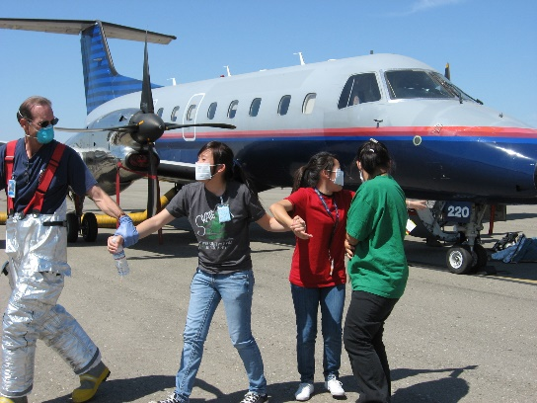
Participate in MRC Disaster Drill

Members can act as injured patients in full-scale exercises and drills. Not only will they get the opportunity to learn about preparedness and emergencies, but they will also gain an understanding of the issues that disaster survivors and victims face. Participating in a local MRC Disaster Drill will improve their ability to perform under pressure and promote safety in communities across the country

Volunteer at Local MRC Flu Shot Clinic

Students could participate at a local MRC flu shot clinic by educating patients about hand washing and disease prevention as they wait for their vaccinations and shots. This can improve the health literacy of the patients.

Lock Down Video
Write, record and edit an informative video that outlines what a school should do in case of a lockdown. This will improve public health preparedness and educate members on how to act under pressure.
Elementary School Visit
Visit the local elementary school to teach younger children about a variety of public health topics, such as healthy eating and exercise, avoiding tobacco use, safety, hygiene, and proper hand washing. This will promote good health and wellness in the younger generations.

Connect on Social Media
Young members could create a Facebook, Twitter, and/or Instagram for the MRC unit. This will promote interest in and raise understanding of the MRC, and could possibly assist with recruitment.

How to Further Existing MRC Relationships

In order to have a successful and sustainable partnership, strive to participate regularly in community events with your local MRC. Encourage members to take initiative within the unit by volunteering to take a leadership role in larger projects.

Introducing the MRC into the Health Science Classroom is a major step in producing an effective partnership. By educating students about public health and the MRC within the health sciences curriculum, it will effectively expose more youth to public health and the MRC. This exposure will promote increased involvement and strengthen the partnership with youth organizations and the local MRC units. See Appendix E for Sample Unit Plan to introduce MRC and related resources into the classroom.
Another way to specifically further the MRC- HOSA relationship is to encourage participation in the MRC Partnership competitive event (guidelines of which can be found at www.hosa.org/node/117), which allows HOSA members to develop a relationship with their local MRC unit. All HOSA chapter activities planned and implemented for this event MUST be done in partnership with the Medical Reserve Corps. If there is no local unit, consider creating a Junior MRC unit.

There are also Public Health, CERT skills, and CPR/First Aid competitive events, which relate to the overarching mission of improving community health and preparedness. There is also a MRC Volunteer Recognition Award, which recognizes outstanding youth volunteers for their service in supporting the mission of the MRC, HOSA, and Office of the Surgeon General. These are great ways for students who work with the MRC to be recognized for their hard work throughout the year.

Next Steps

Establishing a relationship with your local MRC unit can be beneficial to you, your youth, the MRC unit, and your community as a whole. MRC volunteers increase the preparedness and resilience of their communities, as well as educate and inform through supporting numerous public health initiatives. The experience can be incredibly rewarding and beneficial to everyone involved.

If you have further questions, please reach out to your local MRC leaders, the MRC Program office, or MRC units that have been successful in including youth within their units. HOSA-Future Health Professionals is a national student-led organization, which has historically had successful relationships with MRC units. HOSA state advisor information can be found on the HOSA website at www.hosa.org/node/24.

Appendix A
Sample Email to a MRC Unit Leader

Dear (MRC Personnel),
My name is (Insert Advisor Name), I am a Health Sciences teacher and HOSA-Future Health Professionals Advisor at (insert high school). HOSA-Future Health Professionals is a Career and Technical Student Organization catered for secondary and post-secondary/collegiate members who are interested in pursuing a career in the health care field. Our HOSA chapter is very involved in our community: volunteering at 5k’s, hosting blood drives, and educating community members about current health issues in our community. This is one of the many reasons our HOSA chapter is interested in partnering with the Medical Reserve Corps.
We would like to invite you to be a guest speaker in our Health Sciences classes to educate them about the MRC. We are also hosting a community wide Health Fair and would like for your unit to set up a booth and also present on (insert topic). This partnership will benefit the MRC’s efforts in engaging more youth to impact the community. Raising awareness can push members to lend a helping hand, experience volunteering with the MRC and consider a career in public health. Our connection will be enriching for your network, our school and our local community.
Please let us know if you are interested in visiting our HOSA chapter and assisting us with our Health Fair. We look forward to the possibility of working with you in the future.

Thank you,

(Insert Advisor Name)
(Address)
(Phone Number)

Appendix B
Sample MRC Parent Information Handout
*please note that this handout will have to be tailored to each specific unit depending on the unit/organization collaboration mission and agreement
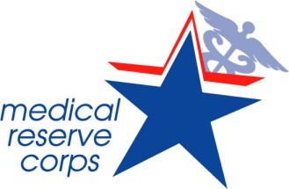

A partnership has been formed between the Medical Reserve Corps (MRC), HOSA-Future Health Professionals (HOSA), and the Mid-Missouri Area Health Education Centers (MAHEC) to form a Junior Medical Reserve Corps (Junior MRC). Provided is information regarding the organization, mission, frequently asked questions, required forms, and some examples of volunteer activities that may be organized throughout the year.

Mission of the Medical Reserve Corps (MRC): To engage volunteers to strengthen public health, emergency response and community resiliency.

Mission of the Junior MRC: To encourage students to develop the skills and expertise needed to improve the health of their community and train them to be Missouri’s future health leaders.

About MRC:
The MRC is a national program made up of community-based units that organize volunteers with the intent to prepare and react to emergencies and encourage healthy practices throughout the year. Currently, there are 997 units across the country with over 200,000 volunteers. In the state of Missouri, there are 33 units with over 1,000 volunteers. Working under the Office of the U.S. Surgeon General, the goals in non-emergent times are to improve health literacy, eliminate health disparities, improve disease prevention, and develop public health preparedness. It is instrumental in both emergent and non-emergent times. Volunteers include both medical and non-medical individuals.

Junior MRC:
Plan: Working in partnership with HOSA, MAHEC, the local MRC and the newly formed Junior MRC, students will be encouraged to be involved in improving their community and its citizens.

During this partnership, the students will have opportunities to actively participate in health campaigns, clinics, emergency preparedness drills, and work to disseminate important health information to various individuals from the youth to the elderly.

With the foundation of this program in volunteerism, it has a focus that promotes emergency preparedness and response. During non-emergent times, the focus is on encouraging healthy practices, promoting disease prevention, and improving health literacy.

FAQs

Why join the Junior MRC?
In addition to gaining experience and exposure to the importance of helping others and the value of being prepared, there is much to gain for the students. This experience provides an introduction to various professions, allows the students the opportunity to provide health and preparedness education to peers and community members, participate in training and drills, and allows students to use these experiences to build a resume for future education goals and jobs.

Will I really make a difference?
Not only will the experience be rewarding and a great opportunity to explore how each individual can make a difference for local citizens, it also gives students the exposure to the importance of preparation and community involvement. Many individuals benefit greatly from the efforts of volunteers in educating and providing awareness of healthy practices and emergency preparedness. Participation in the program allows each student to contribute towards the advancement of public health priorities such as prevention of injury and disease, improving public health emergency preparedness, and promoting health knowledge. Additionally, being a part of this group shows an ongoing commitment as a healthcare professional.

Will my child be at risk?
Junior MRC participants will be limited in their exposure and expectations and will not be left alone or be subjected to any high-risk activities. The students will only be actively involved in situations that keep them safe and they will be working alongside adult volunteers, ensuring safety.

What kind of activities will be involved?
Junior MRC members will be involved in educating both peers and community members. Activities may include representation and assistance at local fairs and clinics, and involvement with local schools and elderly care facilities. Members can participate in emergency drills or exercises and complete projects in various areas to improve the community. Some of the projects may include collecting food for the needy, providing emergency kits or education pamphlets, educate others on nutrition or fitness, teaching first aid, educating on infection control practices and promoting disease prevention.

What is the time commitment?
Students will be required to meet all training modules and participate in one volunteer/teaching activity per semester.

Appendix C

Sample MRC Unit/Housing Organization Consent Form

This form must be returned to MRC Unit/Housing Organization prior to participating in any Medical Reserve Corps activity if you are under 18 years of age.

I grant approval for my child, __________________________, Age ______, Grade Level _________, Date of Birth____________, to participate in MRC Unit/Housing Organization-sponsored classes and Medical Reserve Corps activities and release MRC Unit/Housing Organization, the Medical Reserve Corps and any instructors, activity leaders, and assistants from any liability arising from his/her participation in said activities. I understand MRC Unit/Housing Organization does not provide health or medical insurance for participants. Consent is hereby given to the MRC Unit/Housing Organization and Medical Reserve Corps instructors, activity leaders, and supervisors to give or seek medical aid required in the case of emergency.

My son/daughter has permission to participate in the following activity:

__________________________________ on this date: _________________

Health Insurance Company: _________________________________________

Policy Number:__________________________

Parent/Guardian Signature: _________________________________________ Date: ________________

Parent’s Name (print): ______________________________________________

Phone: (_______) ________________________________

Name and Phone of additional person who may be contacted in case of emergency:

Name: __________________________ Phone: ____________________

Please return to: MRC Unit/Housing Organization address Or fax to: (xxx) xxx-xxxx
You may also bring this consent form the day of the activity.
NOTE: This form was developed by the University of New Mexico (UNM) Center for Disaster Medicine (CDM) for youth participating in MRC activities. The CDM is the housing organization for the Albuquerque-UNM MRC, which works with youth by partnering with youth organizations.

Appendix D

Potential Barriers/Solutions

Who is responsible for the liability or risk that comes with including youth members?
- Many school/community organizations already have youth liability forms/waivers/insurance policies for their members. As the advisor, you should have access to these and you may be able to use these forms for MRC unit activities. If you do not, contact your school administrators or organization headquarters.
- Check to see if the MRC unit housing organization provides any coverage for youth volunteers
- Always obtain parental permission for volunteers younger than 18 years old
- Always consider if MRC activities are appropriate to involve youth
- A sample consent form is included in Appendix C

What if the parents or guardians are worried about letting their child join a MRC unit?
- Provide parents a fact sheet of possible activities that their child may be participating in and/or a “parent information handout” (sample in Appendix B) before the child registers with the MRC unit. Also let them know that their child will not be “deployable” in emergency or disaster situations
- Require a parental permission slip for each event that the child participates in
- Hold a parent information/question session and explain the roles and duties that the youth may have
- Ask the parent to join the MRC as well!

I don’t have enough time or money to coordinate youth volunteers on top of my regular duties.
- Organizing volunteers takes time and resources (either or both of which an MRC may be lacking). One solution is to see if any adult MRC members want to take charge of being a youth volunteer coordinator.
- You can also try finding a student “chapter liaison” from your organization and have them act as a bridge between you and the MRC unit leader, while having them coordinate the students’ involvement with the adult MRC members

The MRC unit leader says there are too many administrative tasks involved with beginning the process of partnering with an MRC unit.
- Involve student council, the students themselves, and/or parental organizations to determine rules and regulations
- Decrease costs spent on training the youth members by including them in training that is already happening within the MRC unit. You can also suggest training students to become trainers in certain activities

The MRC unit leader is worried about communicating with my organization and the youth.
- Tell them that this is an opportunity! You can discuss with the youth and the MRC unit leader to determine the best way to communicate between all of you, and test it out if you have never used it before.
- Some possible routes: texting, Facebook (creating a group, page, or message thread), Twitter

The MRC unit leader is worried that students joining and leaving the unit every year will be disruptive and/or a waste of MRC unit resources.
- Some MRC units have trained students to be trainers of certain modules: this can help reduce some training costs incurred by the need to train new students every year. Advisors/sponsors can also be trained as trainers, and can train students within in the classroom or organization meetings.
- Ensure the leader that students can volunteer for multiple years, especially if they start early! This is also a great way to increase the MRC unit’s future adult healthcare professional participation

Youth have erratic schedules that are not conducive to partnering with a MRC unit (which mostly only includes adults)
- If the youth school schedule is a barrier to coordinating events, there is plenty that can be accomplished on weekday evenings or during the weekend. In fact, that is when most adult MRC members are able to help out as well!

It is not convenient to partner youth with an organization that is not located on school grounds.
- Coordinate activities with the MRC that are located around the school
- Discuss with the student “chapter liaison” to organize possible carpooling options for students whose parents may not be able to provide transportation for them. Adult MRC members may be able to help out as well
- Activities done with your school organization may be considered a field trip by the school. School may cover the transportation costs for these ‘real-world’ experiences with the MRC

Can the MRC trust youth to get the job done?
- Start off the youth with small, simple tasks. Involve them in events that are already planned where they can succeed easily. As you and the MRC unit get to know them and their abilities, discuss with the MRC unit leader to increase their responsibilities accordingly. This will help raise their credibility not only to the MRC unit, but also to the community

Can the MRC unit and I trust the youth to keep sensitive matters confidential?
- Require all new youth members to complete a HIPAA training module
- Have youth sign a confidentiality agreement upon joining the MRC and explain the significance
- Avoid assigning youth to tasks that involve confidential or sensitive information

How do I make sure that the youth are accountable?
- Be sure to emphasize that students must show up to events that they sign up for, and not being responsible for their actions will result in consequences and possible removal from future activities
- If necessary, have the youth sign a contract before engaging them in the MRC unit

Appendix E

Sample Lesson Plan/Curriculum
OBJECTIVES
- Students will gain knowledge of the Medical Reserve Corps through research, presentations and participation with a local MRC Unit.
- Students will partner with local MRC Unit to plan and/or participate in a MRC activity.

DAILY LESSON PLAN OUTLINES
Day One:
Introduce MRC through a ten question pre-test to determine pre-existing student knowledge of MRC. Discuss the answers for the formative pre-test as a class. Introduce the MRC through MRC PowerPoint.
Day Two:
Show the MRC website to students. (www.medicalreservecorps.gov) View the following videos with students: MRC Overview, Forging Relationships-MRC and Public Health Services, and Fall 2008-Deployment Training Video. Discuss the impact of the MRC on communities. (https://medicalreservecorps.gov/videoFldr/Videos#overview)
Day Three:
MRC Scavenger Hunt-Students will locate all information utilizing the website.
Day Four:
Guest Speakers: Local MRC Unit Members

Day Five-Six:
Plan/Participate in activity with local MRC Unit. (See Youth Engagement Toolkit for ideas/resources)
Day Seven-End of Project:
Assign students a final project based on their research. Students should be given ample time to develop the final project.

ASSESSMENT
Formative: Feedback should be given consistently as students are researching, during class discussion and during preparation of final project.
Summative: Final project (essay or other assignment/activity)

Medical Reserve Corps: Online Scavenger Hunt

Using the MRC website (www.medicalreservecorps.gov ), answer each of the following questions.

- What is the MRC?
- Why was the MRC created?
- How many MRC units are there nationwide?
- How many volunteers comprise the MRC?
- Describe five activities that MRC volunteers can participate in in their own communities.

- Using the most recent MRC IN FOCUS, describe two events MRC units were involved in. What impact do you feel this had on the local community?
- Locate the News and Events section. Read two of the articles in the latest news, and describe what occurred. Specifically look for any articles related to youth involvement in the MRC.
- Where is the closest local unit to our school?
- A local doctor has asked you why they should volunteer in the MRC. Explain how it is beneficial to not only the community, but to each volunteer also.
- What do MRC volunteers do?
- Who has the current volunteer spotlight? Why did he/she join?
- Leadership is important in MRC Units. What four areas of leadership does MRC training focus on?
- How can someone start a new MRC unit?
- How do you join an already existing MRC?
- How can you recruit for a local MRC unit?
- The MRC and the American Red Cross partner together to reach common goals. What activities do they support each other with? Why is this important?
- Who is the Regional Coordinator for our area?
- Who is our State Coordinator?

Medical Reserve Corps Final Projects
Project One: Persuasive Essay
Why should youth organizations become active members in their local Medical Reserve Corps Unit? After researching the resources located on the Medical Reserve Corps website and planning/participating in a local MRC activity, write a persuasive essay supporting your position with evidence from your experiences and research.

Project Two: Mock Disaster Drill
Partnering with your local MRC Unit and local emergency management teams, plan and participate in a mock disaster drill at your school.

Project Three: Community Health Fair
Partnering with your local MRC Unit and local health professionals, plan a local health fair for your community. Your research should show what health concerns are prevalent in your area. Based on findings, each group should plan a presentation and/or a poster presentation on that topic for the health fair. As a class, all aspects of health should be covered.

Public Health Resources for the Classroom
Department of Health and Human Services
- www.hhs.gov

Office of the Surgeon General
- www.surgeongeneral.gov/
- Initiatives: www.surgeongeneral.gov/initiatives/index.html
- Reports and Publications: www.surgeongeneral.gov/library/index.html

U.S. Public Health Commissioned Corps
- www.usphs.gov

Medical Reserve Corps
- MRC: www.medicalreservecorps.gov

Public Health Emergency
- www.phe.gov/preparedness/Pages

National Association for County and City Health Officials
- NACCHO: www.naccho.org

Disaster Health Information Resources
- Hazmat/CBRN Response
  - WISER: www.wiser.nlm.nih.gov (Wireless Information System for EMS)
  - CHEMM: www.chemm.nlm.nih.gov (Chemical Hazards Emergency Mgmt.)
  - REMM: www.remm.nlm.gov (Radiation Emergency Medical Mgmt.)

- Disaster Health Literature
  - www.disasterlit.nlm.nih.gov (Resources/Documents)
  - www.pubmed.gov (Journal References)
  - www.eai.nlm.nih.gov (Free publications during disasters)

- Disaster Health Links
  - www.disaster.nlm.nih.gov/topics
  - www.medlineplus.gov or www.medlineplus.gov/spanish

- Disaster Health Apps
  - www.disaster.nlm.nih.gov/apps

- Public Health Emergency
  - www.phe.gov

NIH Resources
- National Library of Medicine: www.nlm.nih.gov
- National Cancer Institute: www.cancer.gov
- National Eye Institute: www.nei.nhi.gov
- National Heart, Lung and Blood Institute: www.nhlbi.nih.gov
- National Human Genome Research Institute: www.genome.gov
- National Institute on Aging: www.nia.nih.gov
- National Institute of Biomedical Imaging and Bioengineering: www.nibib.nih.gov
- National Institute of Child Health and Human Development: www.nichd.nih.gov
- National Institute on Drug Abuse: www.nida.nih.gov
- National Institute of General Medical Sciences: www.nigms.nih.gov
- National Institute of Nursing Research: www.ninr.nih.gov
- National Center for Complementary and Alternative Medicine: www.nccam.nih.gov
- National Institute for Senior Health: www.nihseniorhealth.gov

Partner to Heal
- www.health.gov/hai/training.asp

U.S. Department of Agriculture and U.S. Department of Health and Human Services
- Dietary Guidelines
  - www.dietaryguidelines.gov
  - www.ChooseMyPlate.gov
  - www.health.gov/dietaryguidelines
  - www.healthfinder.gov

- Eat Healthy, Be Active Community Workshops Curriculum
  - http://www.health.gov/dietaryguidelines/workshops/DGA_Workshops_Complete.pdf

