MRC Unit Leader Guide to
Youth Engagement in the
Medical Reserve Corps

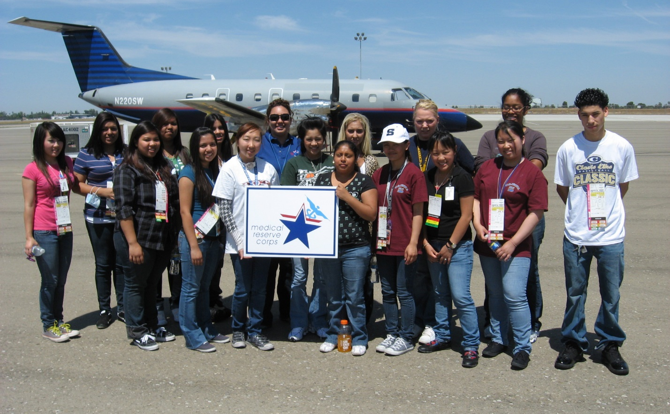

Table of Contents

Why Engage Youth? 3
Benefits of Youth Engagement for MRC Units and the Community
Testimony from a MRC Regional Coordinator

What Can the MRC and Youth Do Together? 5
Sample Activities

How to Engage Youth in Your MRC Unit 6
Allow Youth to Join as a Member of Your MRC Unit
Partner with a Student or Community Organization
Support the Creation of a Junior MRC Unit

How to Further Existing Youth Relationships 9

Next Steps 9

Appendices 10-15
Appendix A – School and Community Youth Organizations
Appendix B – Medical Reserve Corps Parent Information Handout
Appendix C – Sample MRC Unit/Housing Organization Consent Form
Appendix D – Potential Barriers/Solutions

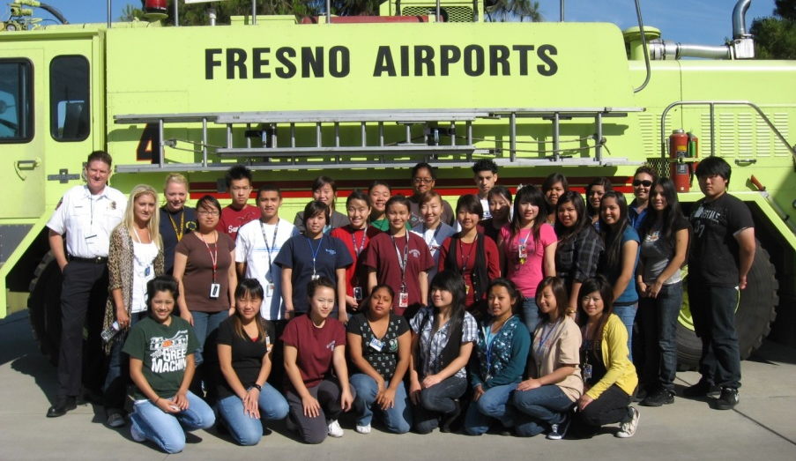

Why Engage Youth?

Young people make important contributions to communities in many ways, and an increasing number of youth want to participate in public health initiatives and activities. Youth engagement considers the perspectives and ideas of our future generations, and it involves taking risks, listening, sharing and working together for the greater good. Their participation is able to not only improve the health and preparedness of your community, but also help them develop leadership, service and other skills. Allowing youth to participate in activities with your Medical Reserve Corps (MRC) unit is a fantastic way to engage and expose these future generations of volunteers, leaders and health professionals to public health, as well as a great way to increase the outreach and impact of your unit.

Many organizations, such as HOSA—Future Health Professionals, Boy and Girl Scouts, and 4-H (see Appendix A for a list of other organizations), are looking for opportunities to learn and serve in their communities. These organizations frequently require their students to engage in community service projects, and some have even trained their youth in HIPAA and OSHA guidelines. Many of these students ready, willing and able to serve their communities—and they are ideal candidates to support the mission of the Medical Reserve Corps.

Why Should Youth Engage in Public Health and with the Local MRC

The field of public health can offer great personal fulfillment to young people: working towards improving the health and wellbeing of their community is quite often a rewarding endeavor. As an MRC unit leader, you play a key role in encouraging student volunteerism efforts both as youth and later as professionals in their chosen fields. Helping youth become involved with your local MRC unit is a fantastic way to utilize existing infrastructure to allow them to have “real world” experience within public health while still in school.

Benefits of Youth Engagement for MRC Units and the Community

- Increased self-esteem, leadership, development of professional/medical skills

- More volunteers for non-emergency events
- Increased public health initiatives and preparedness events
- Learning from youth
- Youth bring energy and excitement to assigned tasks
- Youth who volunteer are more likely to be actively involved in community projects as an adult—that means you are developing the future pool of MRC volunteers!
- Bridging the “generation gap”
- New perspectives and increased awareness
- Increased sense of community
- Renewed motivation and commitment to the MRC after witnessing passionate youth

Testimony from a MRC Unit Leader

We’ve definitely had to overcome some hurdles when it comes to partnering with HOSA groups, the biggest of which being 1) liability concerns; 2) my Housing Organizations requires volunteers to be at least 18 years of age, which pretty much excludes most of the HOSA members. However, not being one to give up easily I continued to research and learned that in my area, HOSA activities that are performed as a group and supervised by their advisor or health science teacher is considered a school project/field trip, so we were able to use this to both (MRC and HOSA) our advantage and have created successful partnerships with several local HOSA teams.

In addition to assisting with our Annual Volunteer Recognition event and acting as patients/victims in our full-scale POD exercise, HOSA students have assisted with several specialized projects including:

Food Desert Survey - Assisting Tarrant County Public Health (TCPH) officials with conducting a in Tarrant County using the Texas Environment Nutrition Assessment. "Food Desert is a term used to describe an area with little or no access to large grocery stores that offer fresh and affordable foods needed to maintain a healthy diet".

Affordable Care Act Notifications – Assist TCPH Preventative Medicine staff with contacting individuals (via phone) who were possible candidates for insurance under the Affordable Care Act (ACA) to notify them of 1) the upcoming deadline for enrollment; and 2) provide information on where individuals can go for further assistance on using the ACA website and enrollment process.

Vietnamese Translation Project - we have a large Vietnamese population in our area and one of our local HOSA chapters has several Vietnamese speaking students who have volunteered their time and knowledge to translate written preparedness materials into Vietnamese.
Because I manage such a large number of MRC volunteers and have numerous HOSA groups in our area, organization is key, so it helps to have a volunteer management system that is customizable and allows me to create a custom group fields so I can 1) easily identify HOSA students; and 2) send emails to subgroups (i.e. HOSA) about volunteer opportunities that appropriate for their age and skill level The youth that volunteer through their local HOSA groups have been a big help to our MRC unit!

–Monica Tipton, Tarrant County (TX) MRC

What the MRC and Youth Do Together

There are a variety of activities that youth can be involved with in the MRC. Below are a few examples of such activities. For a more extensive list, see the Youth Engagement Toolkit, Section 3: Activity Bank.

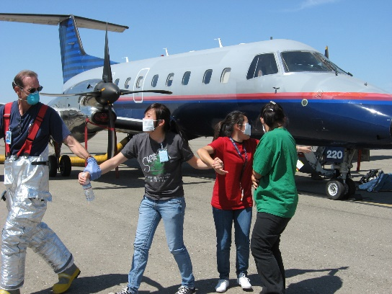
Participate in MRC Disaster Drill
Youth members and partners can act as injured patients in full scale exercises and drills. Not only will they get the opportunity to learn about preparedness and emergencies, but they will also gain an understanding of the issues that disaster survivors and victims face. Participating in a local MRC Disaster Drill will improve their ability to perform under pressure and promote safety in communities across the country.

Volunteer at a Local MRC Flu Shot Clinic
Students could participate at a local MRC flu shot clinic by educating patients about hand washing and disease prevention as they wait for their vaccinations and shots. This can improve the health literacy of the patients.

Lockdown Video
Write, record and edit an informative video that outlines what a school should do in case of a lockdown. This will improve public health preparedness and educate members on how to act under pressure.

Elementary School Visit
Visit the local elementary school to teach younger children about a variety of public health topics, such as healthy eating and exercise, avoiding tobacco use, safety, hygiene, and proper hand washing. This will promote good health and wellness in the younger generations.

Connect on Social Media
Young members could create a Facebook, Twitter, and/or Instagram for your MRC unit. This will promote interest in and raise understanding of the MRC, and could possibly assist with recruitment.

How to Engage Youth in Your MRC Unit

There are three different ways that your MRC unit can engage with local youth, including allowing youth to join your unit, partnering with a local school/community youth organization, or supporting the creation of a Junior MRC unit. Below is an overview of how to implement each option, though the experience of each organization will vary.

Join an MRC Unit

If your MRC unit is able to allow the membership of volunteers younger than 18 years old, consider the following steps to build a strong youth presence in your unit:

- Reach out to the student advisor of a local school or community-based youth organization (see Appendix A for some suggestions). Explain what the MRC is, why you want to engage their organization in the MRC, and what role the youth could have within your unit. See if you can attend one of the organization’s general body meetings to introduce the MRC and gauge interest.
- Another simple way to get your foot in the door is to extend an invitation to the student advisor to your next general membership meeting. Ask them to attend, and then explain where the students could help the MRC unit as well as benefit from it.
- Provide interested students and parents with Medical Reserve Corps Parent Information Handout (see Appendix B for a sample)
- Have all interested members (including the student advisor) fill out the MRC member application with parental approval. If liability waivers or consent forms are necessary (check with your housing unit insurance policy for youth), have the students and their parents fill those out as well (see Appendix C)
- Propose activities that youth can plan and participate in. The Youth Engagement Toolkit Section 2: Quick Start Topic Guide has a few “hot topics” that youth can learn and educate the community about. Section 3: Activity Bank also contains a list of successful activities conducted by MRC units and youth in the past.
- Grow and expand the relationship as the MRC unit and the youth become more familiar with each other!

Partner

- Reach out to the student advisor of a local school or community-based youth organization (see Appendix A for some suggestions). Explain what the MRC is, why you want to engage their organization in the MRC, and what role the youth could have within your unit. See if you can attend one of the organization’s general body meetings to introduce the MRC and gauge interest.
- Another simple way to get your foot in the door is to extend an invitation to the student advisor to your next general membership meeting. Ask them to attend, and then explain where the students could help the MRC unit as well as benefit from it.
- Once both parties decide to go forward with involving youth in your unit, create an agreement and a plan. Who carries liability? What are the roles that the youth will have in MRC activities? What are the requirements for students to be involved? How will the leaders communicate?
- Once partnership terms are established between you and the advisor, provide parents with Medical Reserve Corps Parent Information Handout (see Appendix B for a sample handout)

- Have the youth and their parents complete any liability waiver/consent forms that are necessary (see Appendix C for a sample)
- Start the engagement process by participating in events or trainings that are already being implemented by your unit
- Propose activities that youth can plan and participate in. The Youth Engagement Toolkit Section 2: Quick Start Topic Guide has a few “hot topics” that youth can learn and educate the community about. Section 3: Activity Bank also contains a list of successful activities conducted by MRC units and youth in the past.
- Grow and expand the partnership as the MRC unit and the youth become more familiar with each other!

Create a Junior MRC Unit

- Contact your MRC Regional Coordinator (contact information can be found on the MRC website under the “Units” tab)
- If necessary, help the youth find a housing organization for the Junior MRC unit
- Assist them with the application process for starting a MRC unit
- If the Junior MRC unit is approved, partner with them. Invite them to attend various preparedness exercises, public health initiatives, training sessions, and any other activities conducted by your MRC unit. Some additional possible activities and project ideas can be found in the Youth Engagement Toolkit under Section 3: Activity Bank

These are very general guidelines for creating a working relationship between a youth organization and your MRC unit. The most important steps to be successful are to go into the process with a plan, and be persistent. There is a list of potential barriers that you may encounter, and some possible solutions, in Appendix D. If you have a question that has not been answered, contact your MRC regional/state coordinator or the MRC program office for help (contact information found on www.medicalreservecorps.gov/FindMRC). They can also put you in contact with student organization chapters or MRC units that have been previously successful in this endeavor.

How to Further Existing Youth Organization Relationships

In order to have a successful and sustainable partnership, strive to have the youth participate regularly in community events with your local MRC. Encourage members to take initiative within the unit by offering youth the opportunity to take a leadership role in larger projects. They are very capable of helping lead projects and can exceed expectations when given the chance.
A specific way to further the relationship with HOSA-Future Health Professionals is to participate in the HOSA competitive events. There is a MRC Partnership competitive event (guidelines of which can be found at www.hosa.org/node/117), which allows HOSA members to further develop their relationship with your MRC unit. All HOSA chapter activities planned and implemented for this event MUST be done in partnership with your unit.

There are also Public Health, CERT skills, and CPR/First Aid competitive events, which relate to the overarching mission of improving community health and preparedness. The MRC Volunteer Recognition Award also exists to recognize outstanding youth volunteers for their service in supporting the mission of the MRC, HOSA, and Office of the Surgeon General. These are great ways for students who work with the MRC to be recognized for their hard work throughout the year.

Don’t forget to report all of your activities, including those that involve youth, on your MRC unit profile! This helps share your successes and spreads great ideas to others looking to engage youth!

Next Steps

Establishing a relationship with your local student or community organization can be beneficial to the youth, your MRC unit, and the community as a whole. MRC volunteers increase the preparedness and resilience of their communities, as well as educate and inform through supporting numerous public health initiatives. The experience can be incredibly rewarding and beneficial to everyone involved.

If you have further questions, please reach out to your local MRC state/regional coordinators, the MRC Program office, or MRC units that have been successful in including youth within their units. Also, consider using the MRC listserv (sign up here: https://www.medicalreservecorps.gov/searchFldr/ListservRulesRegulations) to post questions or concerns.

HOSA-Future Health Professionals is a national student-led organization which has historically had successful relationships with MRC units. HOSA state advisor information can be found on the HOSA website at www.hosa.org/node/24.

Appendix A

Possible Partners - School and Community-Based Organizations

School-Based and Career and Technical Student Organizations

HOSA—Future Health Professionals www.hosa.org
Business Professionals of America www.bpa.org
DECA (Marketing) www.deca.org
Future business Leaders of America www.fbla-pbl.org
Future Educators Association www.fea.org
Family, Career & Community Leaders of America www.fccla.org
National FFA (Agriculture) www.ffa.org
SkillsUSA (Trades and Industrial) www.skillsusa.org
Technology Student Association www.tsa.org
National Association of Student Councils www.nasc.org
National Honor Society www.nhs.us
Key Club (affiliated with Kiwanis) www.keyclub.org

Also consider any pre-medicine clubs, service clubs, etc.

Community-Based Organizations

Boy Scouts of America www.scouting.org
Girl Scouts of the USA www.girlscouts.org
Boys and Girls Clubs of America www.bgca.org
National 4-H Council www.4-h.org
Civil Air Patrol Cap Teens www.gocivilairpatrol.com/teens.htm
Camp Fire USA www.campfireusa.org

Also consider any other youth groups, church groups, etc. that may be involved with service

Appendix B
Sample MRC Parent Information Handout
*please note that this handout will have to be tailored to each specific unit depending on the unit/organization collaboration mission and agreement
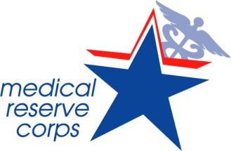

A partnership has been formed between the Medical Reserve Corps (MRC), HOSA—Future Health Professionals (HOSA), and the Mid-Missouri Area Health Education Centers (MAHEC) to form a Junior Medical Reserve Corps (Junior MRC). Provided is information regarding the organization, mission, frequently asked questions, required forms, and some examples of volunteer activities that may be organized throughout the year.

Mission of the Medical Reserve Corps (MRC): To engage volunteers to strengthen public health, emergency response and community resiliency.

Mission of the Junior MRC: To encourage students to develop the skills and expertise needed to improve the health of their community and train them to be Missouri’s future health leaders.

About MRC:
The MRC is a national program made up of community-based units that organize volunteers with the intent to prepare and react to emergencies and encourage healthy practices throughout the year. Currently, there are 997 units across the country with over 200,000 volunteers. In the state of Missouri, there are 33 units with over 1,000 volunteers. Working under the Office of the U.S. Surgeon General, the goals in non-emergent times are to improve health literacy, eliminate health disparities, improve disease prevention, and develop public health preparedness. It is instrumental in both emergent and non-emergent times. Volunteers include both medical and non-medical individuals.

Junior MRC:
Plan: Working in partnership with HOSA, MAHEC, the local MRC and the newly formed Junior MRC, students will be encouraged to be involved in improving their community and its citizens. During this partnership, the students will have opportunities to actively participate in health campaigns, clinics, emergency preparedness drills, and work to disseminate important health information to various individuals from the youth to the elderly.

With the foundation of this program in volunteerism, it has a focus that promotes emergency preparedness and response. During non-emergent times, the focus is on encouraging healthy practices, promoting disease prevention, and improving health literacy.
FAQs

Why join the Junior MRC?
In addition to gaining experience and exposure to the importance of helping others and the value of being prepared, there is much to gain for the students. This experience provides an introduction to various professions, allows the students the opportunity to provide health and preparedness education to peers and community members, participate in training and drills, and allows students to use these experiences to build a resume for future education goals and jobs.

Will I really make a difference?
Not only will the experience be rewarding and a great opportunity to explore how each individual can make a difference for local citizens, it also gives students the exposure to the importance of preparation and community involvement. Many individuals benefit greatly from the efforts of volunteers in educating and providing awareness of healthy practices and emergency preparedness. Participation in the program allows each student to contribute towards the advancement of public health priorities such as prevention of injury and disease, improving public health emergency preparedness, and promoting health knowledge. Additionally, being a part of this group shows an ongoing commitment as a healthcare professional.

Will my child be at risk?
Junior MRC participants will be limited in their exposure and expectations and will not be left alone or be subjected to any high-risk activities. The students will only be actively involved in situations that keep them safe and they will be working alongside adult volunteers, ensuring safety.

What kind of activities will be involved?
Junior MRC members will be involved in educating both peers and community members. Activities may include representation and assistance at local fairs and clinics, and involvement with local schools and elderly care facilities. Members can participate in emergency drills or exercises and complete projects in various areas to improve the community. Some of the projects may include collecting food for the needy, providing emergency kits or education pamphlets, educate others on nutrition or fitness, teaching first aid, educating on infection control practices and promoting disease prevention.

What is the time commitment?
Students will be required to meet all training modules and participate in one volunteer/teaching activity per semester.

Appendix C

Sample MRC Unit/Housing Organization Consent Form

This form must be returned to MRC Unit/Housing Organization prior to participating in any Medical Reserve Corps activity if you are under 18 years of age.

I grant approval for my child, __________________________, Age ______, Grade Level _________, Date of Birth____________, to participate in MRC Unit/Housing Organization-sponsored classes and Medical Reserve Corps activities and release MRC Unit/Housing Organization, the Medical Reserve Corps and any instructors, activity leaders, and assistants from any liability arising from his/her participation in said activities. I understand MRC Unit/Housing Organization does not provide health or medical insurance for participants. Consent is hereby given to the MRC Unit/Housing Organization and Medical Reserve Corps instructors, activity leaders, and supervisors to give or seek medical aid required in the case of emergency.

My son/daughter has permission to participate in the following activity:

__________________________________ on this date: _________________

Health Insurance Company: _________________________________________

Policy Number:__________________________

Parent/Guardian Signature: _________________________________________ Date: ________________

Parent’s Name (print): ______________________________________________

Phone: (_______) ________________________________

Name and Phone of additional person who may be contacted in case of emergency:

Name: __________________________ Phone: ____________________

Please return to: MRC Unit/Housing Organization address Or fax to: (xxx) xxx-xxxx
You may also bring this consent form the day of the activity.

NOTE: This form was developed by the University of New Mexico (UNM) Center for Disaster Medicine (CDM) for youth participating in MRC activities. The CDM is the housing organization for the Albuquerque-UNM MRC, which works with youth by partnering with youth organizations.

Appendix D

Potential Barriers/Solutions

Who is responsible for the liability or risk that comes with including youth members?
- Many school/community organizations already have youth liability forms/waivers/insurance policies for their members. As the MRC unit leader, contact the organization advisor to discuss liability and options
- Check to see if your MRC unit housing organization provides any coverage for youth volunteers
- Always obtain parental permission for volunteers younger than 18 years old
- Always consider if MRC activities are appropriate to involve youth
- A sample consent form is included in Appendix C

What if the parents or guardians are worried about letting their child join a MRC unit?
- Provide parents a fact sheet of possible activities that their child may be participating in and/or a “parent information handout” (sample in Appendix B) before the child registers or partners with your MRC unit. Also let them know that their child will not be “deployable” in emergency or disaster situations
- Require a parental permission slip for each event that the child participates in
- Hold a parent information/question session in conjunction with the student organization advisor and explain the roles and duties that the youth may have
- Ask the parent to join the MRC as well!

I don’t have enough time or money to coordinate youth volunteers on top of my regular duties.
- Organizing volunteers takes time and resources (either or both of which an MRC may be lacking). One solution is to see if any adult MRC members want to take charge of being a youth volunteer coordinator
- You can also try finding a student “chapter liaison” from the youth organization and have them act as a bridge between you and the student organization advisor, while having them coordinate the students’ involvement with the adult MRC members

I am worried about communication with the youth and their organization.
- This is an opportunity! Talk to the young members about the best ways to communicate with them, and conduct some tests to be sure all are comfortable with the process. This is also another possible responsibility for the student chapter liaison
- Some possible routes: texting, Facebook (creating a group, page, or message thread), Twitter

Students joining and leaving the MRC unit every year will be disruptive and/or a waste of my unit resources.
- Some MRC units have trained students to be trainers of certain modules: this can help reduce some training costs incurred by the need to train new students every year. Advisors/sponsors can also be trained as trainers, and can train students within in the classroom or organization meetings

- Students can volunteer for multiple years, especially if they start early! This is also a great way to increase your unit’s future adult healthcare professional participation

Youth have erratic schedules that are not conducive to partnering with a MRC unit (which mostly only includes adults)
- If the youth school schedule is a barrier to coordinating events, there is plenty that can be accomplished on weekday evenings or during the weekend. In fact, that is when most adult MRC members are able to help out as well!

It is not convenient to partner youth with an organization that is not located on school grounds.
- Coordinate activities that are located around or convenient to the school
- Discuss with the student “chapter liaison” to organize possible carpooling options for students whose parents may not be able to provide transportation for them. Adult MRC members may be able to help out as well
- Activities done with your school organization may be considered a field trip by the school. School may cover the transportation costs for these ‘real-world’ experiences with the MRC

Can I trust youth to get the job done?
- Start off the youth with small, simple tasks. Involve them in events that are already planned where they can succeed easily. As you and your unit get to know them and their abilities, discuss with the student advisor to increase their responsibilities accordingly. This will help raise their credibility not only to your unit, but also to the community

Can I trust the youth to keep sensitive matters confidential?
- Require all new youth members to complete a HIPAA training module
- Have youth sign a confidentiality agreement upon joining the MRC and explain the significance
- Avoid assigning youth to tasks that involve confidential or sensitive information

How do I make sure that the youth are accountable?
- Be sure to emphasize that students must show up to events that they sign up for, and not being responsible for their actions will result in consequences and possible removal from future activities
- If necessary, have the youth sign a contract before engaging them in your unit

