Student Guide to
Youth Engagement in the
Medical Reserve Corps

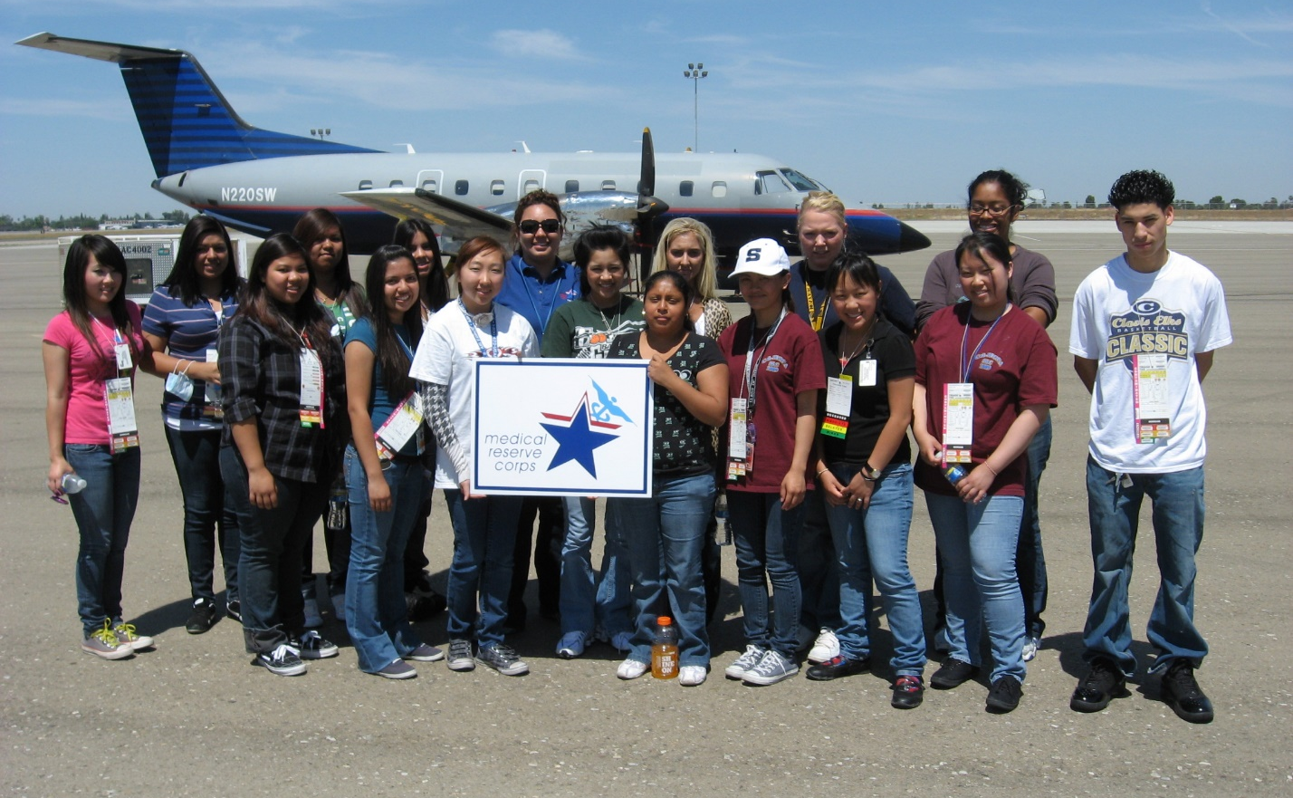

Contents

Introduction to the MRC 3-4
What is Public Health?
What Is the MRC?
Why the MRC Is Needed

Why You Should Engage in Public Health and with the Local MRC 4-5
Benefits of Becoming Involved with the MRC
Testimonial from a Student

How to Engage with the Local MRC 5-6
Join as a Member of a MRC Unit
Partner with the MRC through a Student Organization
Create a Junior MRC

What Can Youth and the MRC Do Together? 7

How to Further Existing MRC Relationships 8

Next Steps 8

Appendices 9-11
Appendix A – Tips for Reaching Out to MRC Leaders
Appendix B – Sample Email: Invitation to MRC Leader to Participate in a School Activity
Appendix C – Sample Email: Partnership Proposal
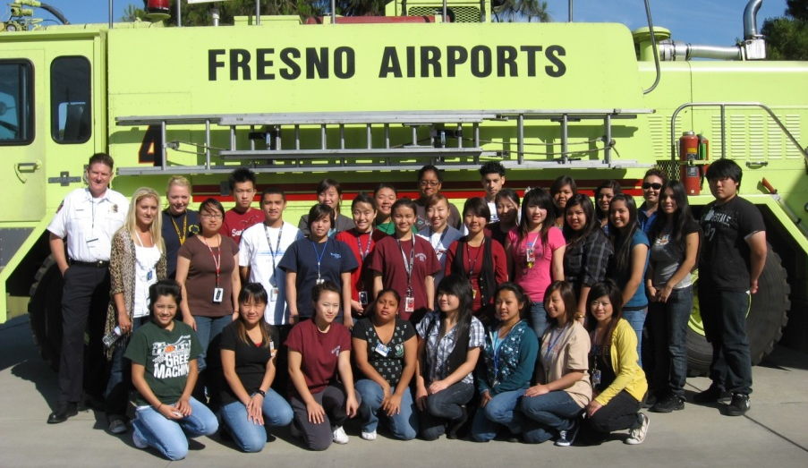

Introduction to the MRC

What is Public Health?

Public health is an exciting and growing field of study that is increasing in importance every day. Public health advocates for health through efforts aligned to prevent disease, increase longevity and improve population health. The field tackles numerous health issues, such as improving access to health care, controlling infectious disease, and reducing environmental hazards, violence, substance abuse, and injury.

Public health professionals come from wide variety educational backgrounds, and are leaders who meet the many exciting—and often complex—challenges in protecting the public’s health both today and in the future.

What is the MRC?

The Medical Reserve Corps (MRC) is a national network of local volunteers whose mission is to strengthen public health, emergency response and community resiliency.

The MRC is primarily comprised of medical and public health professionals from all facets and fields. Through the MRC, volunteers are trained and prepared to assist in the event of a local disaster and are encouraged to participate in community events aimed at strengthening public health and education.

The MRC are made up of a variety of medical and public health professionals as well as other volunteers. Some of the many disciplines represented in the MRC units include:

- Physicians
- Physicians Assistants
- Nurse Practitioners
- Nurses
- Pharmacists
- Dentists
- Veterinarians
- Behavioral Health
- Respiratory Therapists
- Public Health
- Other Disciplines
- Non-Public Health/Non-Medical Volunteers

For more information and/or to find a local MRC near you, visit http://www.medicalreservecorps.gov

Why the MRC is Needed

In times of crisis or disaster—be it a hurricane, a flood, a disease outbreak, or even manmade disaster—medical and public health professionals rush in from all over, eager to volunteer in support of emergency relief activities. What they discovered, though, was that there was no organized approach to identify these volunteers and align everyone’s efforts to be the most effective that they could be in times of emergency. The MRC was established to provide a way to recruit, train, and activate medical and health professionals to respond to community health needs, including disasters and other public emergencies.

Today, almost 1000 MRC units throughout all fifty states in the U.S. support local public health initiatives, as well as prepare for and respond to disaster and emergency situations when disaster strikes their community. From conducting annual flu clinics, to running first aid booths at county fairs, to deploying in hurricane response situations, MRC volunteers are dedicated to increasing the health and resiliency of their communities in every way that they can.

Why You Should Engage with the Local MRC

Youth make important contributions to communities in many ways, and an increasing number of youth are participating in public health initiatives and activities. Your participation not only improves the health and preparedness of the communities, but also helps you develop leadership and service skills. Participating in your local MRC unit is a great way to engage and expose yourself to public health as well as a great way to learn and serve your community.

Even as a student, you can have a large impact on others’ health and lives. Begin making a difference today by engaging with your local MRC unit.

Benefits of Becoming Involved with the MRC

- Increased self-esteem, leadership, development of professional/medical skills

- Introduction to adults: mentorship and shadowing opportunities with community and public health leaders
- Introduction to public health
- Better academic achievement
- Résumé building
- Networking with other youth and professionals
- “Real-world” experience
- New perspectives
- Sense of purpose

Testimonial from a Student

Two years ago, I approached my HOSA advisor about competing in the MRC partnership competition. At the time, I had no idea what the MRC was. I just knew I was interested in public health and wanted to find out more information, so we could put a team together. My advisor was able to locate our local MRC unit leader who came and spoke to our chapter. We were able to partner together to organize volunteer events and recruit new members for our local MRC unit. The mission, work, and dedication of the MRC is astonishing and an experience I will remember forever. I will be able to apply this experience to my future career as a health care provider.
—Kelly Meade, HOSA Member at Summit High School, TN

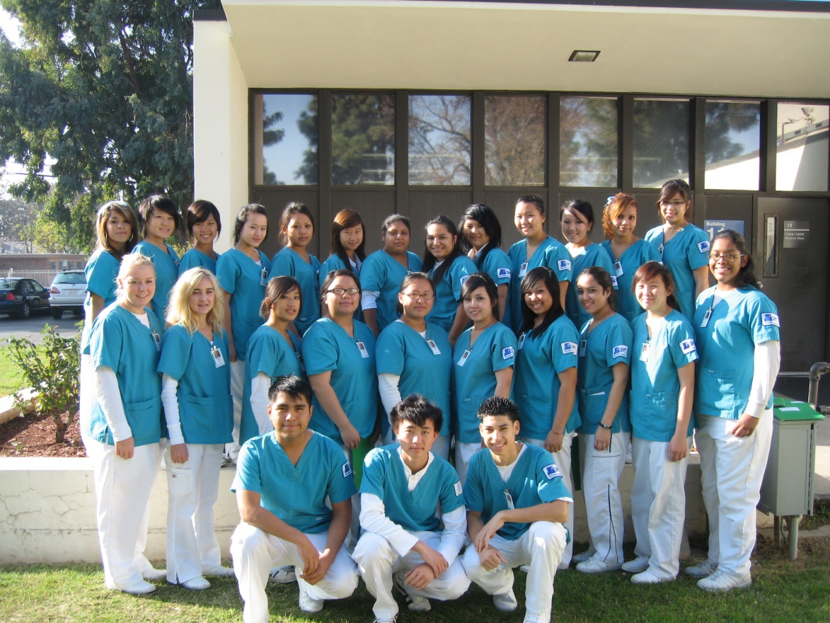

How to Engage with the Local MRC

There are three different ways that you can engage with a local MRC unit, including joining the MRC, partnering with the MRC, and creating a Junior MRC unit. Below is a general overview of how to implement each option, though keep in mind that the experience of each organization will be different.

The most important steps to be successful are to make sure that you read through this guide, provide a copy of the Advisor Youth Engagement Guide to your student advisor, and be persistent. Tips and examples of how to contact MRC unit leaders are located in Appendices A, B and C.

What Can Youth and the MRC Do Together?

There are a variety of activities that youth can be involved with in the MRC. Below are a few examples of such activities. For more ideas, see the Youth Engagement Toolkit, Section 3: Activity Bank.
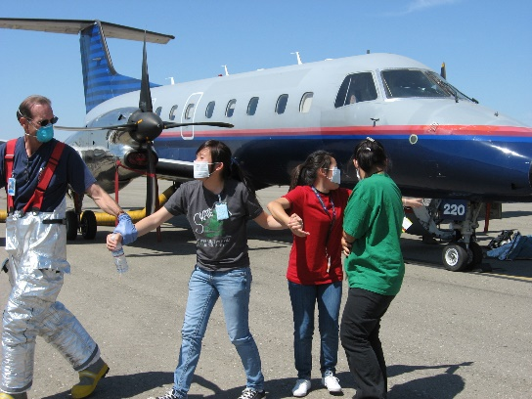
Participate in MRC Mock Disaster Drill
Members can act as injured patients in the large scale health crisis that require immediate medical attention. Students will get the opportunity to learn about preparedness, and emergencies. Participating in a local MRC Disaster Drill will improve ability to perform under pressure and promote safety of communities across the country.

Volunteer at a Local MRC Flu Shot Clinic
Students can participate at the local MRC flu shot clinic by educating patients about hand washing and disease prevention as they wait for their vaccinations and shots. This can benefit quality of health education for patients.

Lock Down Video
Write, record and edit an informative video that outlines what a school should do in case of a lockdown. This will improve public health preparedness and educate members on how to act under pressure.

Elementary School Visit
Visit the local elementary school to teach children about safety, hygiene, and washing hands properly. This will promote good health and wellness in the younger generations.

Connect on Social Media
Create a Facebook, Twitter, and/or Instagram for your local chapter or community group and/or MRC unit. This will promote interest in the MRC and the student organization.

Blood Drive
Organize a blood drive for the local community. This will promote community health and wellness

How to Further Existing MRC Relationships

In order to have a successful and sustainable partnership, strive to participate regularly in community events with your local MRC. Take initiative within the unit by volunteering to take a leadership role in larger projects! You can also encourage other youth organizations to partner with the MRC unit as well! See Appendix C for a sample email suggesting the partnership to another youth organization.
Another way to further the MRC-youth relationship with HOSA chapters specifically is to participate in the HOSA competitive events at the annual HOSA National Leadership Conference. There is a MRC Partnership competitive event (guidelines of which can be found at www.hosa.org/node/117), which allows HOSA members to develop a relationship with their local MRC unit. All HOSA chapter activities planned and implemented for this event MUST be done in partnership with the Medical Reserve Corps. If there is no local unit, consider creating a Junior MRC unit.

There are also Public Health, CERT skills, and CPR/First Aid competitive events, which relate to the overarching mission of improving community health and preparedness. The MRC Volunteer Recognition Award also exists to recognize outstanding youth volunteers for their service in supporting the mission of the MRC, HOSA, and Office of the Surgeon General. These are great ways for students who work with the MRC to be recognized for their hard work throughout the year.

Next Steps

Establishing a relationship with your local MRC unit can not only be beneficial to you and the MRC unit, but also your community as a whole. MRC volunteers increase the preparedness and resilience of their communities, as well as educate and inform through supporting numerous public health initiatives. The experience can be incredibly rewarding and beneficial to everyone involved.

If you have further questions, please reach out to your youth organization student advisor, your local MRC leaders, the MRC Program office, or MRC units that have been successful in including youth within their units.

HOSA-Future Health Professionals is a national student-led organization which has historically had successful relationships with MRC units. HOSA state advisor information can be found on the HOSA website at www.hosa.org/node/24.

Appendix A

Tips for Reaching Out to MRC Leaders

- Professionalism is key when reaching out to others.
You are asking a community leader to help (and possible partner) with you. They want to work with polite, professional students who want to make an impact on their community.

- Introduce Yourself.
Who are you? How did you hear about the MRC? Why do you want to get involved with the MRC?

- Give some background of your past experience with community service.
Inform the leader about what you and your school/organization have been involved in that has impacted your community. This will show them your dedication to service and ability to make a contribution to their unit.

- Be clear and outline what you want the MRC to do for you.
Now that you have reached out, what is your “call to action”? How will their involvement benefit them?

- Include the following:
“This is what we want. This is what we would like you to do. This is what we can accomplish together.”

- Leave them with your contact information.
Give them a way to get in contact with you.

Appendix B
Sample Email: Invitation to MRC Leader to Participate in a School Activity
Dear <MRC Personnel>,

My name is <name here> and I am a member of HOSA-Future Health Professionals at <school name here>. HOSA is a Career and Technical Student Organization catered for secondary and post-secondary/collegiate members who are interested in pursuing a career in the health care field. My HOSA chapter has been very involved in the community: from participating in food collection drives after Hurricane Sandy to hosting blood drives on our campus, we strive to make the strongest positive impact that we can. This is one of the reasons that other members and I are interested in forming a relationship with the Medical Reserve Corps (MRC).

We want to host a career fair at our school. The student body is hoping you can supplement our efforts by attending this event as a representative of the MRC. We would appreciate it if you could help set up a stall, start discussions with students and promote the MRC. This partnership will benefit the MRC’s efforts in involving more youth to impact the community. Raising awareness can push members to lend a helping hand and experience volunteering with the MRC. Our connection will be enriching for both your network and our school community.

Please let us know if you are interested and able to support our event. We look forward to the possibility of working with you in the future.

Thank you,

<Full Name>
<Organization Name>
<Position within the Organization>
<School Name)

Appendix C
Sample Email: Partnership Proposal

Dear <Insert Student Organization Name>,

My name is <name here>, and I am a member of HOSA-Future Health Professionals here at <school name>. Our HOSA chapter currently has a partnership with our local MRC unit, and we would love to have <student organization name> join the partnership.
The Medical Reserve Corps is a national network of local volunteers whose mission is to strengthen public health, emergency response and community resiliency. Our chapter members have been volunteering at events that promote public health and wellness in our community such as feeding the homeless, teaching proper hand washing techniques to local elementary students, collecting personal hygiene items for the women and children’s shelter, among other various activities. We want to help further the overall health of our community by strengthening the efforts of the local youth. There are countless volunteer opportunities available through our partnership with the MRC, and we know your members can benefit from these opportunities.
Please let us know if you are interested in joining our partnership with the local MRC unit. We look forward to the possibility of working with you in the future.

Thank you,

<Full Name>
<Organization Name>
<Position Within Organization>
<School Name>

