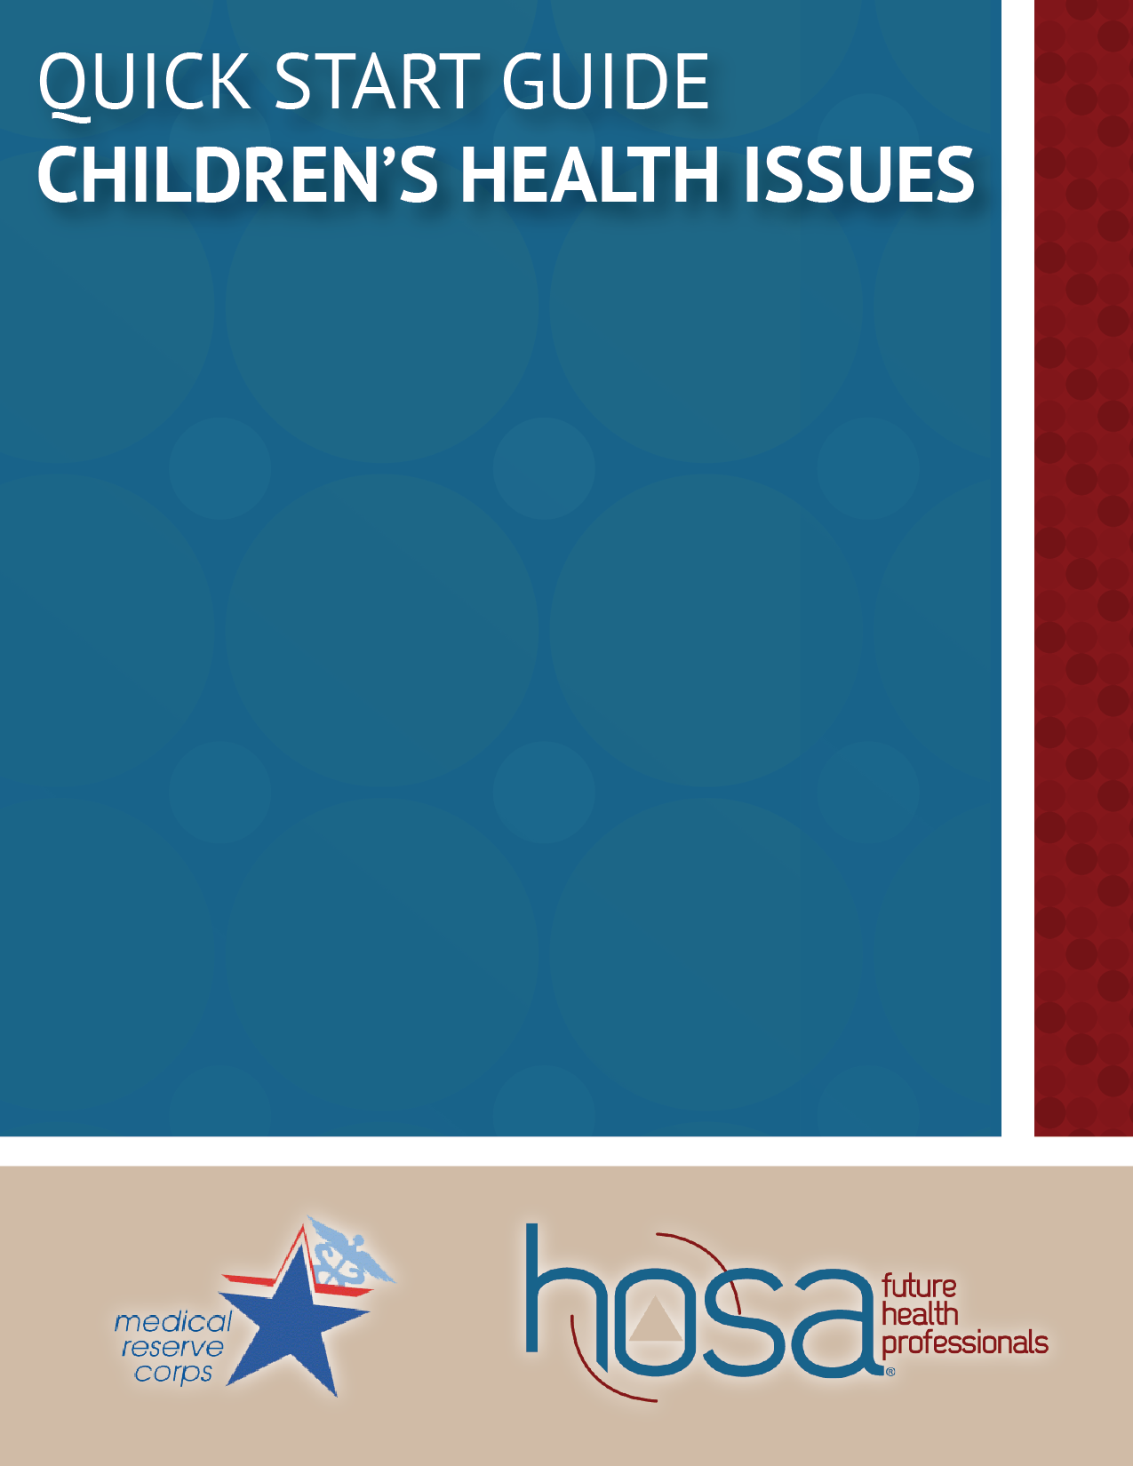

Contents
Introduction 3
Overview

Childhood Health 3-4
Preterm Births
Birth Defects
Immunizations

Childhood Environments 4-5
Development
Child Maltreatment
Nutrition and Food Access
Physical Education and Activity

How to Get Involved 5
National Organizations
Local Actions

Sample Activities 6
Jump Rope for Heart
You Are What You Eat

Introduction

Overview
Health is always a complicated facet of issues, but when it comes to children’s health, the issue gains new dimension. Health and its related outcomes have a great deal of implications for children, as they are developing throughout life. Focusing on these health issues and environmental surrounding throughout the life of a child allows for a holistic approach to addressing children’s health issues.

Childhood health begins at birth, with preterm births and birth defect being who major complications, and continues throughout childhood, with immunizations as a crucial aspect to maintaining health. The environment of the child also affects the childhood development, with child maltreatment, food access, and lack of physical activity being some of the barriers faced by children as they are developing. Addressing these health concerns can better the health of our children and ultimately build a better future.

The health of the children in the United States has implications for all people. As the future of the country, children are a concern of whole countries and communities. Initiatives and actions to protect children’s rights and health are crucial to bettering the future. Be an advocate for those who cannot advocate for themselves!

Childhood Health

Preterm Births
Preterm birth refers to the premature birth of an infant prior to the 37th week of pregnancy. One in every eight infants born in the United States each year are preterm, costing the U.S. health care system more than $26 billion in 2005 in addition to being the leading cause of long-term neurological disabilities in children In 2009, 35% of all infant deaths were accounted for by preterm-related causes. Preterm birth is so dangerous because much of the important growth of fetus occurs in the final weeks and months of pregnancy, including the brain, lungs, and liver. Babies born too early can face serious problems such as breathing problems, feeding difficulties, cerebral palsy, developmental delay, vision problems, and hearing impairment. Preterm births often times cause a heavy emotional and economic burden on families.

Birth Defects
One in every thirty-three babies born in the United States each year is born with a birth defect, a serious condition in which a baby is born with structural changes of the body. Birth defects are the number one cause of infant death in the first year of life, and babies

who survive birth defects often times face lifelong challenges, including problems with physical movement, learning, and social interactions.

Some of the most common birth defects are heart defects, affecting 1 in 100 births, Down syndrome, affecting 1 in 700 births, and cleft palate or lip, affecting 1 in 600 births. Although not all birth defects can be prevented, there are some things that women can do during pregnancy to increase her chances of having a healthy baby and, likewise, to increase the chances of having a baby born with a birth defect. A complex mix of genetics, parental behaviors, and things in the environment causes most birth defects.

Immunizations
Thanks to immunizations, many communicable diseases, such as polio, measles, and tetanus, are at their lowest levels in history. Vaccines help the body build immunity to serious disease without getting sick first, as you would need to without a vaccine. Children in the United States today routinely get vaccines, some of which are required before attending school. There are certain ages at which a vaccine is most effective, so it is important that a child and their parents are in consultation with a doctor to work out the immunization schedule that is necessary for them.

Childhood Environments

Development
Child development occurs primarily in the early years of a child’s life. Healthy development means that children, independent of their abilities, are able to grow up with their social, emotional, and educational needs met. This includes having a safe, loving home and spending time with family as well as maintaining proper nutrition, exercise, and rest. However, these are not always easily attained for all children.

Child Maltreatment
Child maltreatment includes physical abuse, sexual abuse, emotional abuse, and neglect. Each year, local and state agencies receive 3 million reports of child maltreatment, which accounts to nearly six referrals every minute. In addition to incurring a total lifetime cost of $124 billion each year, child maltreatment has detrimental effects on childhood development. This type of abuse and neglect can cause long-standing emotional, neurological, and physical difficulties for the child.

Nutrition and Food Access
Childhood nutrition is especially crucial in ensuring that the body is getting the necessary nutrients for development of the brain and the body. A healthy diet helps a child grow and

learn as well as helps to prevent obesity and weight-related diseases. However, there are some children who do not have consistent access to healthy food or food in general. More than 16 million kinds in the United States live in food insecure households, a household which struggles to put food on the table. One out of five children are affected by hunger, which can prevent them from reaching their full potential.

Physical Education and Activity
Physical activity is another important part of childhood. Children should engage in physical activity for about sixty minutes each day. This physical activity oftentimes occurs in schools for school-aged kids and can often be aided with physical education classes. For some children, school is the only place where they can or will engage in physical activity. For a variety of reasons, certain neighborhoods are less conducive to physical activity than others. This barrier to physical activity puts some children at a disadvantage. This emphasizes the importance of physical education an activity in school to provide children as safe place to run and play.

How to Get Involved

- National Organizations
  - Children’s Defense Fund (childrensdefense.org)
    - A national advocacy group dedicated to promoting the safety and welfare of children.
  - No Kid Hungry (nokidhungry.org)
    - An organization working towards stopping and raising awareness of childhood hunger.
- Local Actions
  - Tutor or mentor local students
  - Volunteer at a local food bank
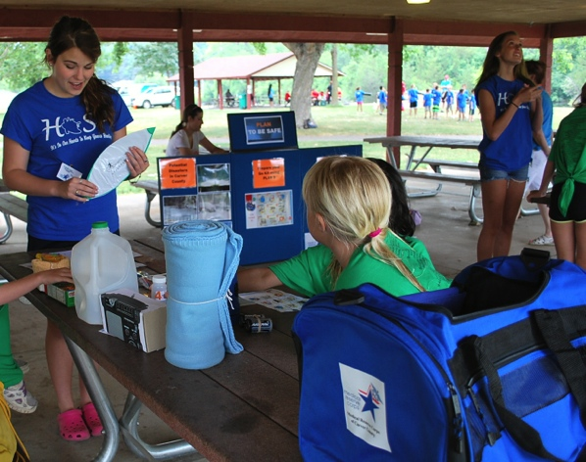

Sample Activities

Jump Rope for Heart
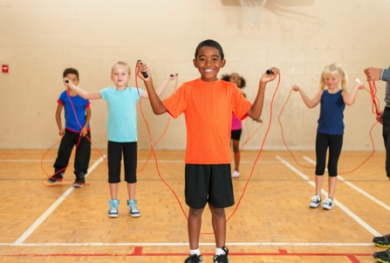
Set up a “Jump Rope for Heart” program at a local elementary school. This can be set up before/after school or during lunch, recess, or P.E. class. This will teach the students one way to be active and have fun at the same time, and you can also take advantage of this opportunity to teach the students about what it means to have a healthy heart.

More ideas here: https://www.heart.org/idc/groups/heart-public/@wcm/@fdr/documents/downloadable/ucm_445538.pdf

You Are What You Eat
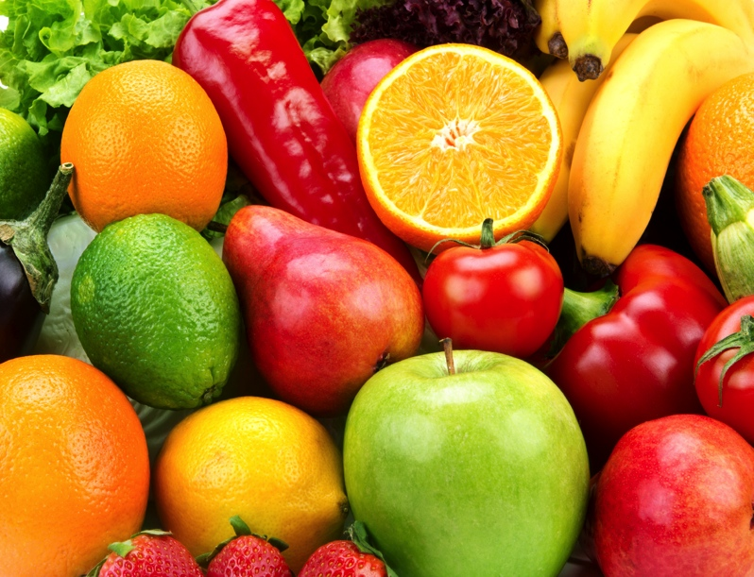
Go to your local elementary school to teach the children about nutrition and how what they eat will affect their body. Have the students create a “vegetable skeleton” to show this in a literal way—and then let them dig in!

