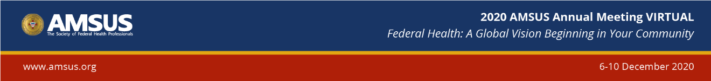

12.9.2020

Together, Ending the HIV Epidemic – A White House Initiative: The Essential Role of Clinicians
CDR Michelle Sandoval- Rosario, DrPH, MPH
PACE Region 9 Director
Office of Infectious Disease & HIV/AIDS Policy
Office of the Assistant Secretary of Health

Watch the presentation- Together, Ending the HIV Epidemic – A White House Initiative: The Essential Role of Clinicians

Answer the following questions in complete sentences.

1) What does the presenter predict regarding HIV infection rates in 10 years if we continue to do what we have done?

2) Identify and describe the four pillars that are key for ending the HIV epidemic.

3) Explain the U=U that is believed to be an important message for all health providers to share.

4) What is PrEP?

5) Why does the presenter say that ending the HIV epidemic must be a whole-of- society initiative?

